

**Micro Control**

**&**

**Robotics**

**Student Portfolio**

**Ceylon German Technical**

**Training Institute**

▪ **Name - ………………………………………………………………………………………………….……………….**

▪ **Admission Number - ……………………………………………………………………………………….…….**

▪ **Course Name - ……………………………………………………………………………………………………….**

▪ **Course Term - ……………………………………………………………...…………………………………………**

**Table of Contents**

01. Pull-up and Pull-down Circuits 4

1. Pull-Up Resistors 4

2. Pull-Down Resistors (to GND) 5

02. Simple Colour Light Circuit 7

03. Knight Rider Circuit 8

04. Turn LED ON and OFF Using One Push Button 9

05. Analog Input Value Check 10

05.1. Code for Check Analog Input Value 10

06. Volume Level Controller with Potentiometer 11

07. Liquid Crystal Display LCD 12

07.1. LCD I2C (I²C) 12

07.2. I2C Adress Chart 12

08. Set Cursor Selection 13

08.1. For 16x2 Display 13

08.2. For 20x4 Display 13

09. Battery Charging Indicator with I2C and Potentiometer 14

10. Horizontal Battery Charging Indicator with I2C and Potentiometer 16

11. Ultrasonic Sensor 18

12. Ultrasonic Distance Count 18

13. Ultrasonic Distance Count with LED Indicators 19

14. Seven Segment Display 20

15. Combining Two Seven Segment Displays 22

16. Joystick Module 28

17. Control LED’s Brightness Using Joy Stick 29

18. Pulse Width Modulation (PWM) 31

19. Motor Driver L298N 32

20. Control Motor with Joy Stick Using L298N Motor Driver 34

21. Control Motor Using Potentiometer 34

22. Control Speed of the Motor Using L298N Motor Driver 34

23. Control Simple Robot Car’s Two Motors 35

24. Data Types 36

24.1 byte 36

24.2. int 36

24.3. long 37

24.4. float 37

24.5. bool 38

24.6. double 38

24.7. char 38

24.8. string 39

24.9. Array 39

25. Servo Motor 42

26. Servo Motor 43

27. Servo Motor with Potentiometer 43

28. Servo Motor with Push Button 43

29. Relay Module 44

30. LDR Sensor Module 46

31. IR Sensor Module 47

32. Key Pad 49

33. Key Pad with Password 50

34. DHT22/11 Temperature and Humidity Sensor 52

35. DHT22 Sensor with I2C Display 53

36. Stepper Motor 54

37. Brushless DC Motor 56

38. Arduino Software Serial 57

39. Blootooth Module 58

40. Communication of 2 UNO Boards 60

40.1. Master Arduino’s Code 60

40.2. Slave Arduino’s Code 61

40.3. Control LED Using 2 Arduino Boards as Master and Slave 62

41. Encoder Module 63

41.1. Encoder and Counter 65

41.2. Encoder 1-5 Count 66

41.3. Encoder with Counter and LCD 68

42. Arduino UNO Board 70

42.1. Digital Input/Output Pins 71

42.2. Analog Input Pins 71

42.3. Microcontroller 71

42.4. Arduino Uno Board Specifications 72

42.5. Logical Operators 72

1. For Loop - 73

2. While Loop - 74

43. Electrically Erasable Programmable Read-Only Memory (EEPROM) 75

44. Gyroscope 76

45. Real-Time Clock Module (RTC) 78

46. Load Cell Sensor 80

47. PCB Designing 82

47.1. Rectifier Circuit 82

47.2. Arduino Board Design Using ATMega 328p 83

# 01. Pull-up and Pull-down Circuits

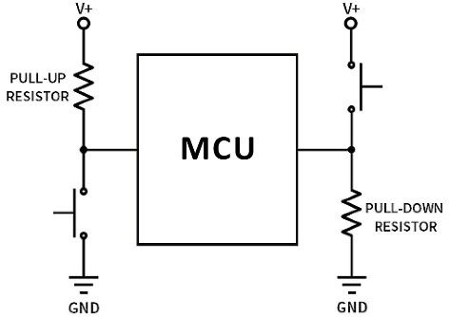

* Pull-up and pull-down resistors are used in digital circuits to ensure that a pin or signal line is at a defined logic level (HIGH or LOW) when it is not actively driven by another component.

## Pull-Up Resistors

• Connected between the signal line and VCC.

• Ensures the signal remains HIGH when no other device is actively pulling it LOW.

Example: A push button with a pull-up resistor

When the button is not pressed, the resistor pulls the input to HIGH.

When the button is pressed, it connects to GND, making it LOW.

## Pull-Down Resistors (to GND)

• Connected between the signal line and GND.

• Ensures the signal remains LOW when no other device is actively pulling itHIGH.

• Used in circuits where a switch or sensor needs to default in LOW.

Example: A push button with a pull-down resistor:

When the button is not pressed, the resistor pulls the input to LOW.

When the button is pressed, it connects to VCC, making it HIGH.

**With Pull-up resistor With Pull-down resistor**

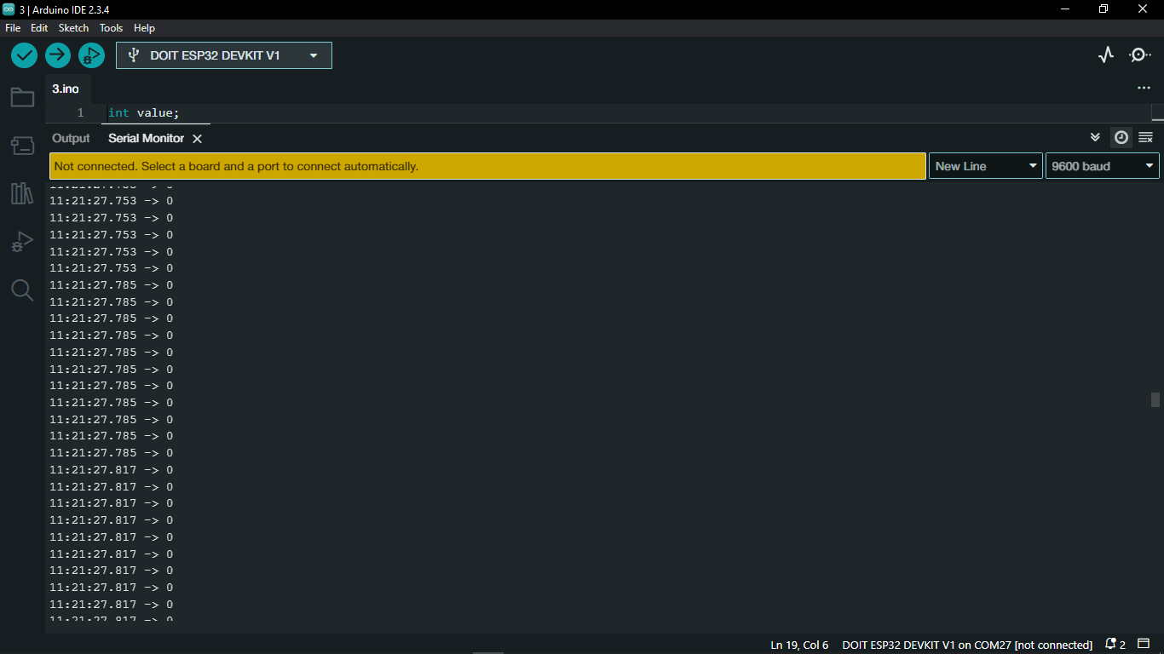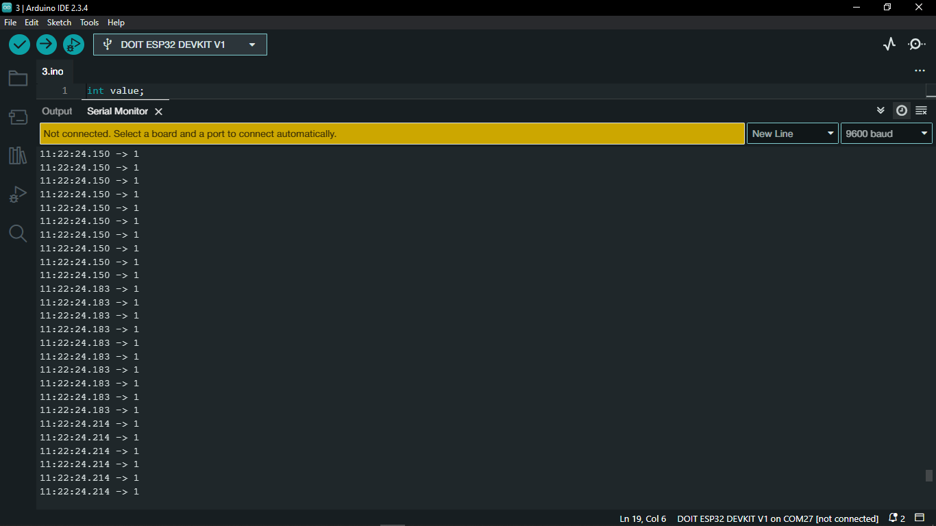

* The code use for check current state of push button is showing bellow.

**With physical pull-up/down Resistor With enabling internal pull-up Resistor**

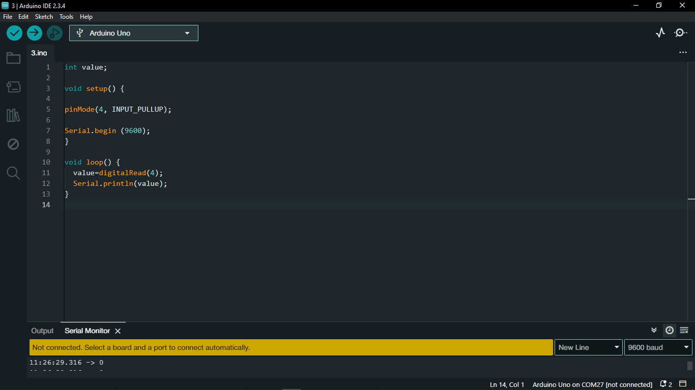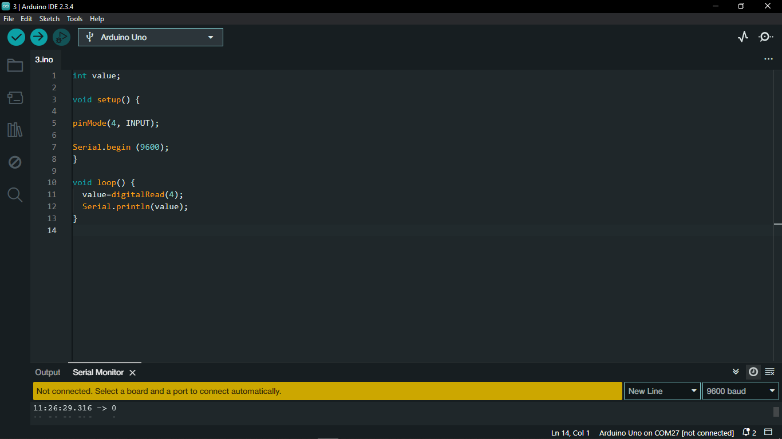

# 02. Simple Colour Light Circuit

#define time1 4000

#define time2 2000

#define time3 8000

void setup() {

 pinMode (13, OUTPUT); //Red

 pinMode (12, OUTPUT); //yellow

 pinMode (11, OUTPUT); //Green

 pinMode (10, OUTPUT);

}

void loop() {

  digitalWrite (10,1);

  digitalWrite (13, 1);

   delay (time1);

  digitalWrite (12, 1);

   delay (time2);

  digitalWrite (13, 0);

  digitalWrite (12, 0);

  digitalWrite (11, 1);

   delay (time3);

  digitalWrite (11, 0);

  digitalWrite (12, 1);

   delay (time2);

  digitalWrite (12, 0);

}

# 03. Knight Rider Circuit

int b = 3;

void setup() {

  pinMode(3, OUTPUT);

  pinMode(4, OUTPUT);

  pinMode(5, OUTPUT);

  pinMode(6, OUTPUT);

  pinMode(7, OUTPUT);

  pinMode(8, OUTPUT);

  Serial.begin (9600);

}

void loop() {

  while (b < 9) {

    digitalWrite (b, 1);

    digitalWrite (b-1, 0);

    b++;

    delay(50);

  }

  while(b > 2) {

    digitalWrite(b, 0);

    digitalWrite (b-1, 1);

    b--;

    delay(50);

  }

}

# 04. Turn LED ON and OFF Using One Push Button

//LED ON/OFF using one push button

int a;

int b=1;

void setup() {

 Serial.begin(9600);

 pinMode(4, INPUT);

 pinMode(13, OUTPUT);

}

void loop() {

  a=digitalRead(4);

  Serial.print("a=");

  Serial.print(a);

  Serial.print("    b=");

  Serial.println(b);

  if ((a==1)&&(b==1)) {

    digitalWrite(13, 1);

    b=0;

    delay(1000);

  }

  else {

    if((a==1)&&(b==0)) {

     digitalWrite(13, 0);

     b=1;

     delay(1000);

  }

}

}

# 05. Analog Input Value Check

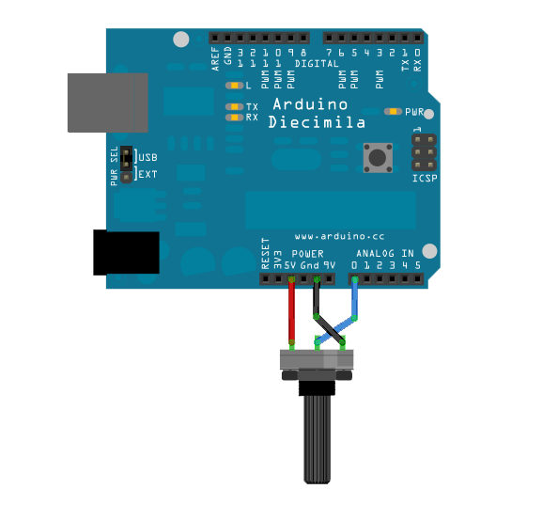

## 05.1. Code for Check Analog Input Value

//Analog input value checking

int a;

void setup() {

  Serial.begin(9600);

}

void loop() {

  a = analogRead(A0);

  Serial.println(a);

}

# 06. Volume Level Controller with Potentiometer

//volume level controller with POT

int b;

int a;

void setup() {

  pinMode(3, OUTPUT);

  pinMode(4, OUTPUT);

  pinMode(5, OUTPUT);

  pinMode(6, OUTPUT);

  pinMode(7, OUTPUT);

  pinMode(8, OUTPUT);

  Serial.begin(9600);

}

void loop() {

  b = analogRead(A0);

  a = map(b,1023,0,9,2);

  Serial.print(a);

  Serial.println(b);

  digitalWrite(a, 1);

  digitalWrite(a-1, 0);

}

# 07. Liquid Crystal Display LCD

## 07.1. LCD I2C (I²C)

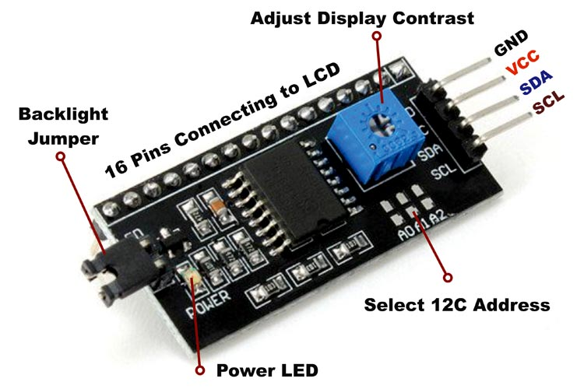

## 07.2. I2C Adress Chart

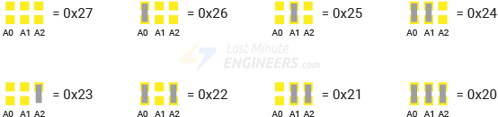

# 08. Set Cursor Selection

## 08.1. For 16x2 Display

|  |  |  |  |  |  |  |  |  |  |  |  |  |  |  |  |
| --- | --- | --- | --- | --- | --- | --- | --- | --- | --- | --- | --- | --- | --- | --- | --- |
| 0 | 1 | 2 | 3 | 4 | 5 | 6 | 7 | 8 | 9 | 10 | 11 | 12 | 13 | 14 | 15 |
| 1 |  |  |  |  |  |  |  |  |  |  |  |  |  |  |  |

Example:

If I Want to select the yellow colour location I can simply write

setCursor (5,1);

## 08.2. For 20x4 Display

|  |  |  |  |  |  |  |  |  |  |  |  |  |  |  |  |  |  |  |  |
| --- | --- | --- | --- | --- | --- | --- | --- | --- | --- | --- | --- | --- | --- | --- | --- | --- | --- | --- | --- |
| 0 | 1 | 2 | 3 | 4 | 5 | 6 | 7 | 8 | 9 | 10 | 11 | 12 | 13 | 14 | 15 | 16 | 17 | 18 | 19 |
| 1 |  |  |  |  |  |  |  |  |  |  |  |  |  |  |  |  |  |  |  |
| 2 |  |  |  |  |  |  |  |  |  |  |  |  |  |  |  |  |  |  |  |
| 3 |  |  |  |  |  |  |  |  |  |  |  |  |  |  |  |  |  |  |  |

# 09. Battery Charging Indicator with I2C and Potentiometer

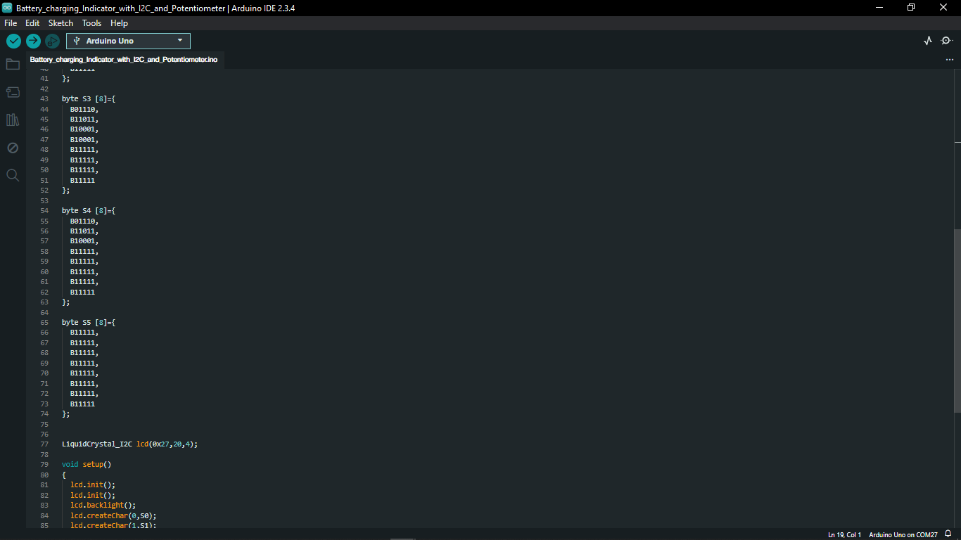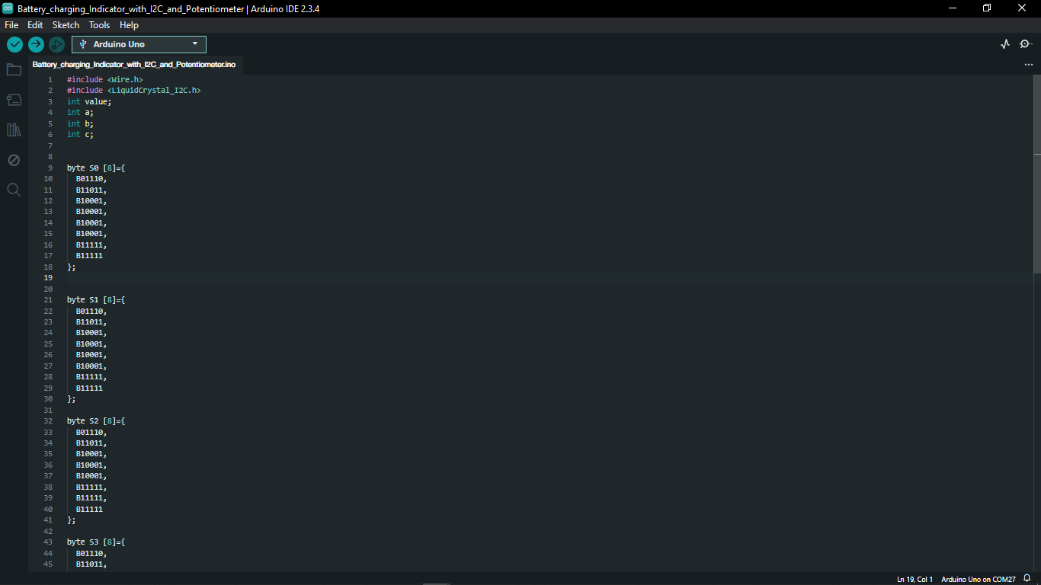

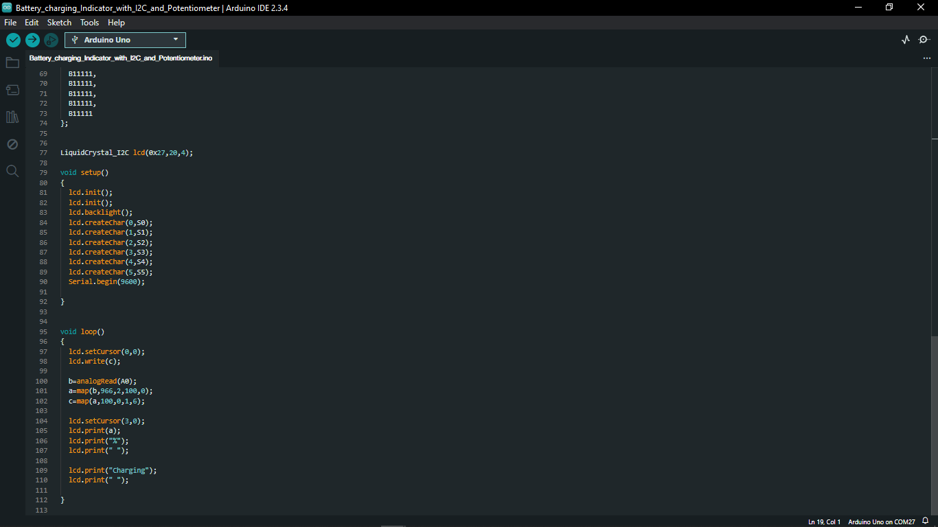

# 10. Horizontal Battery Charging Indicator with I2C and Potentiometer

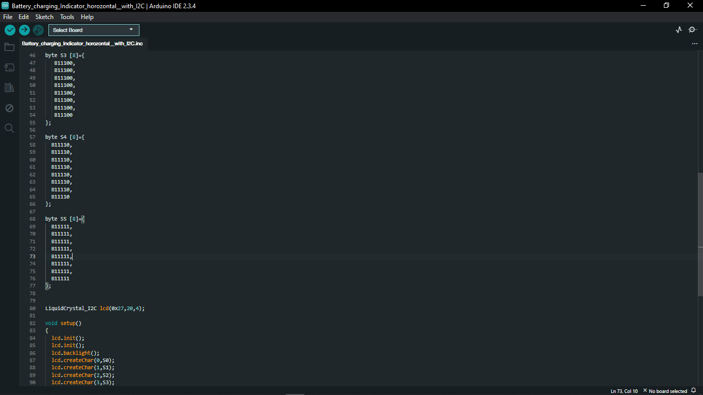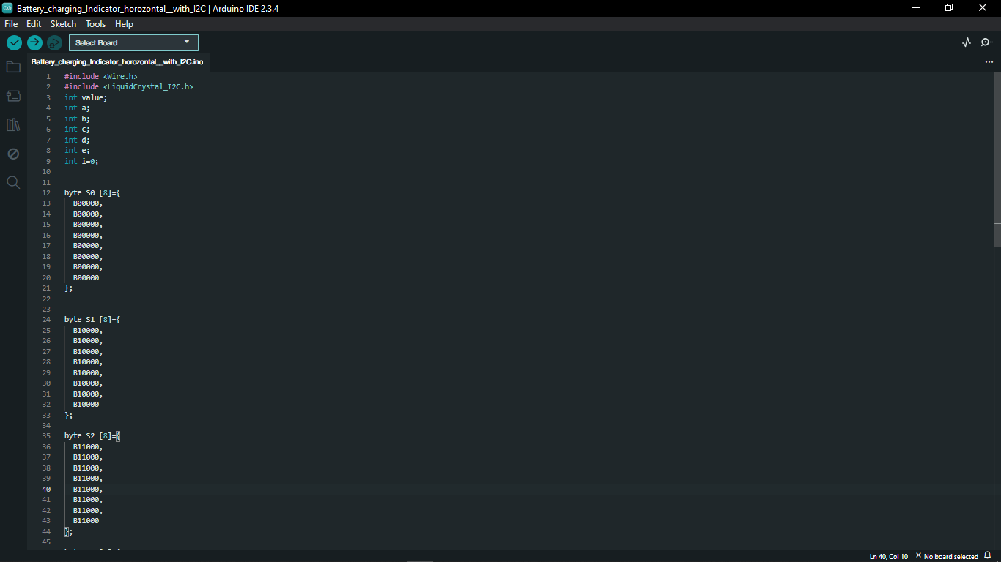

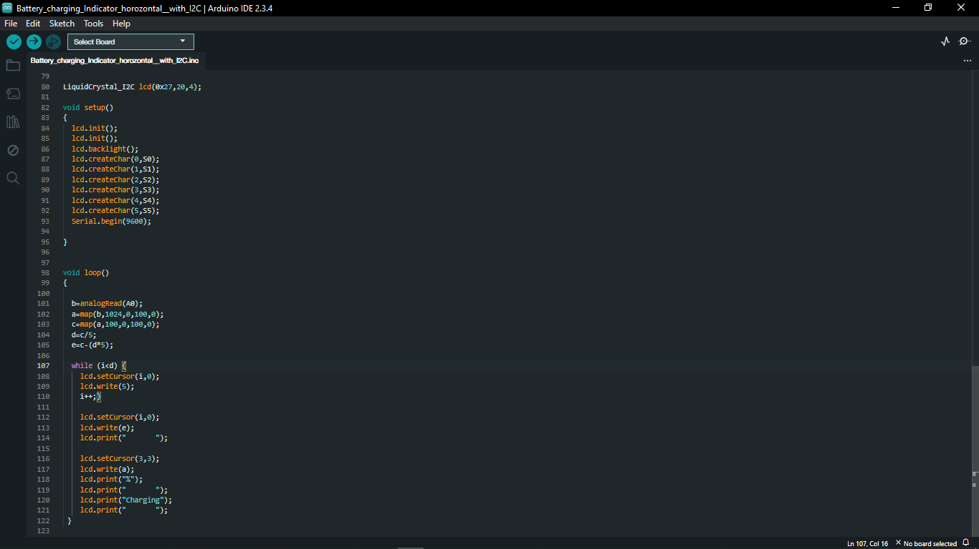

# 11. Ultrasonic Sensor

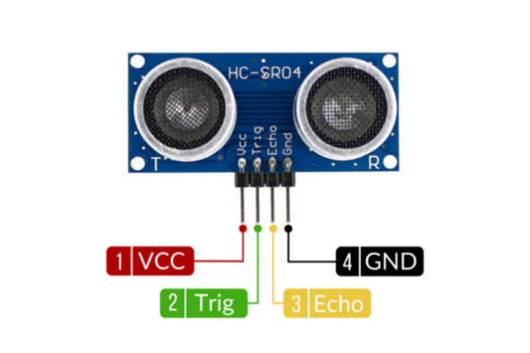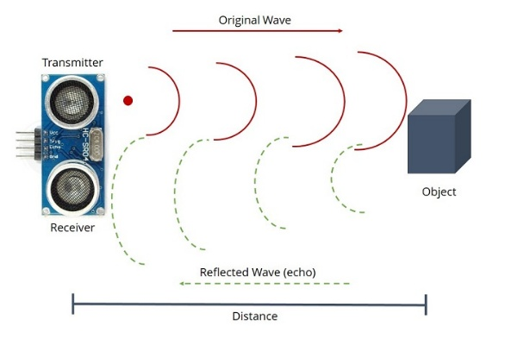

* Ultrasonic sensor calculates the target’s distance by emitting ultrasonic sound waves and converting them into electrical signals.

# 12. Ultrasonic Distance Count

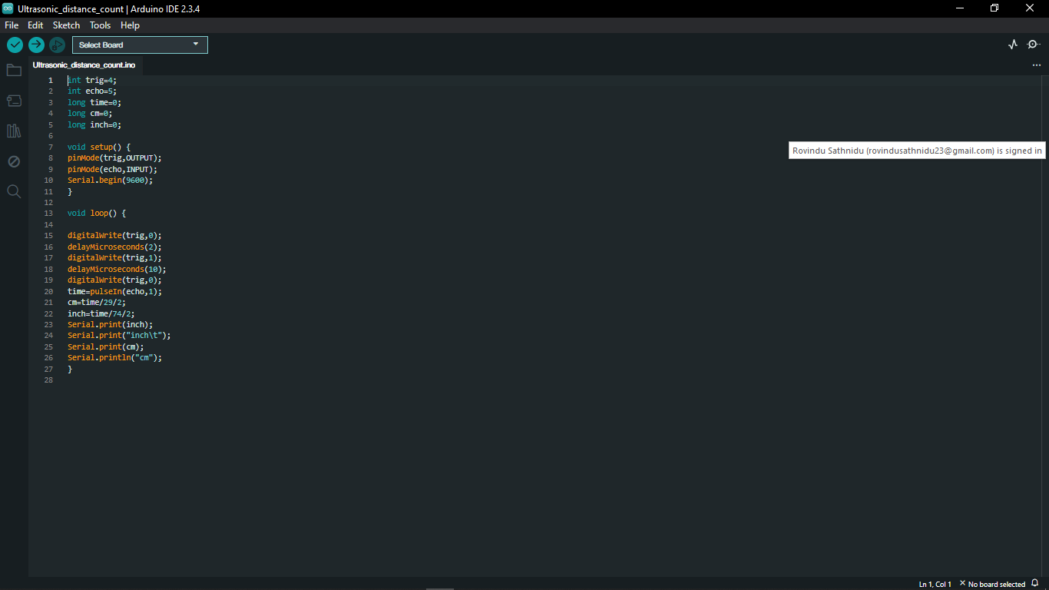

# 13. Ultrasonic Distance Count with LED Indicators

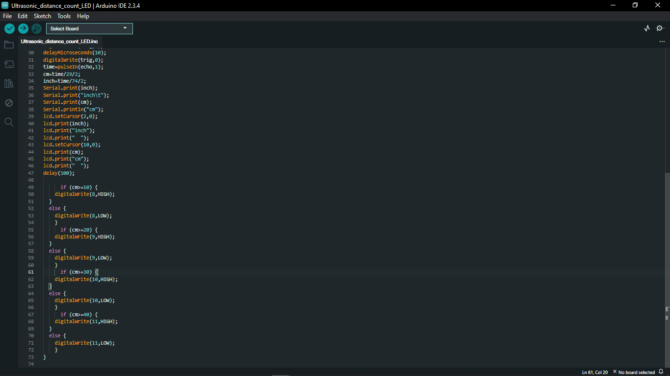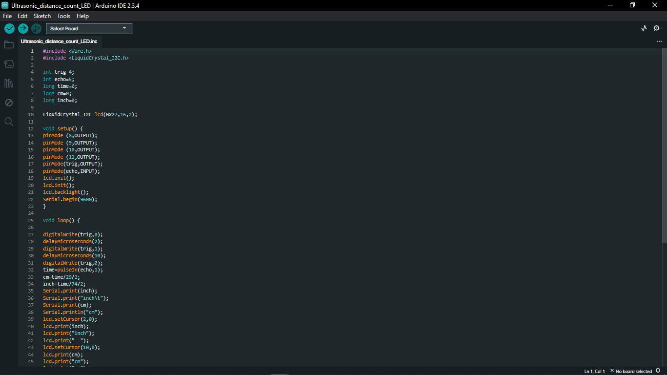

# 14. Seven Segment Display

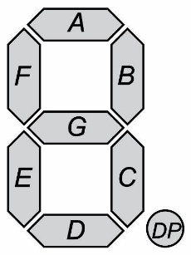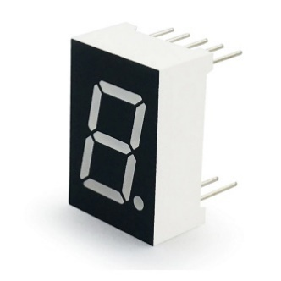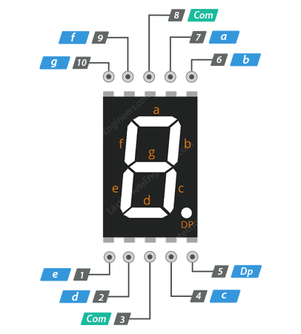

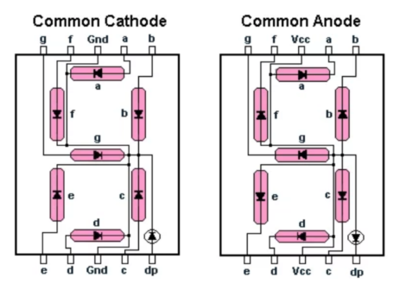

* Seven segment display is an electronic display device used to show decimal numbers from 0 to 9. It consists of seven segments.

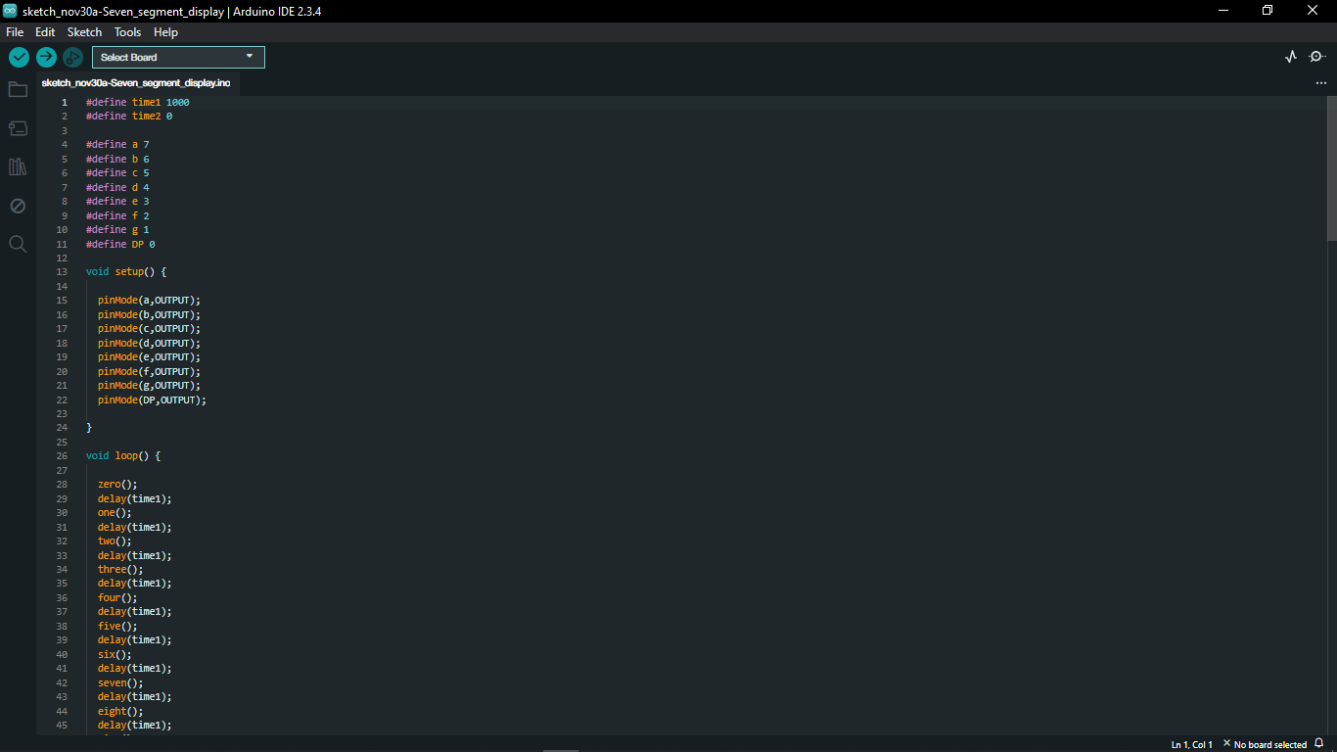



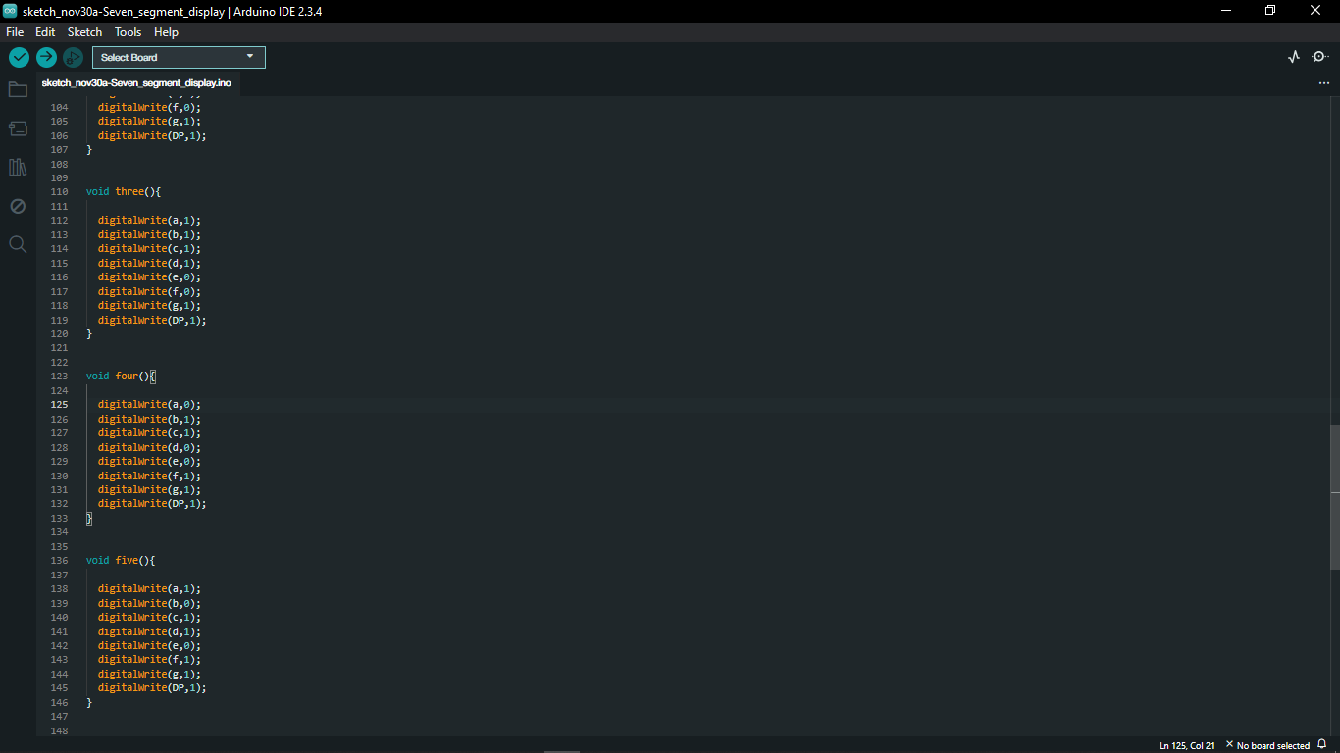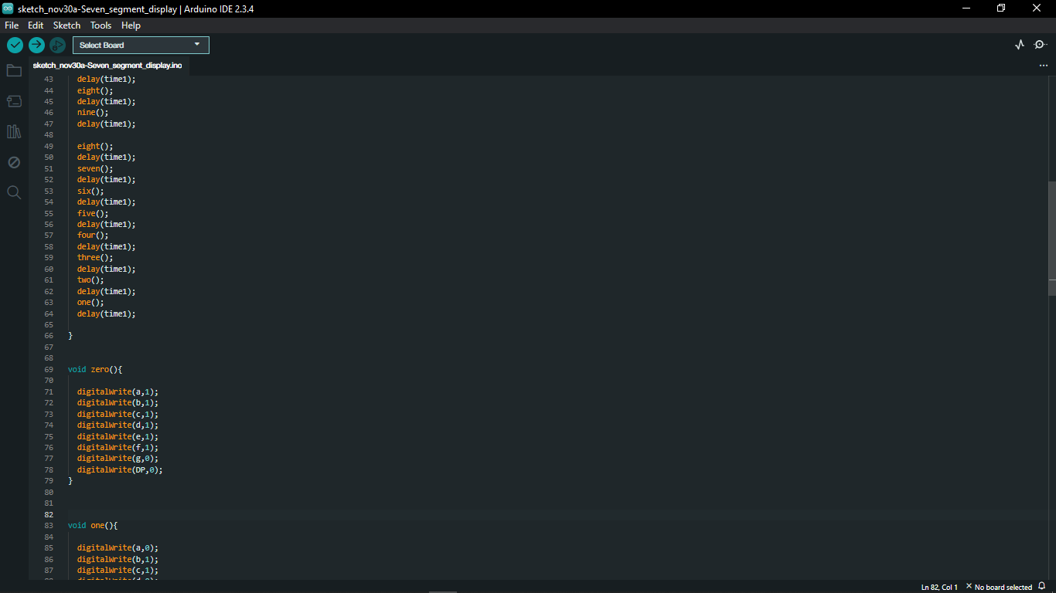

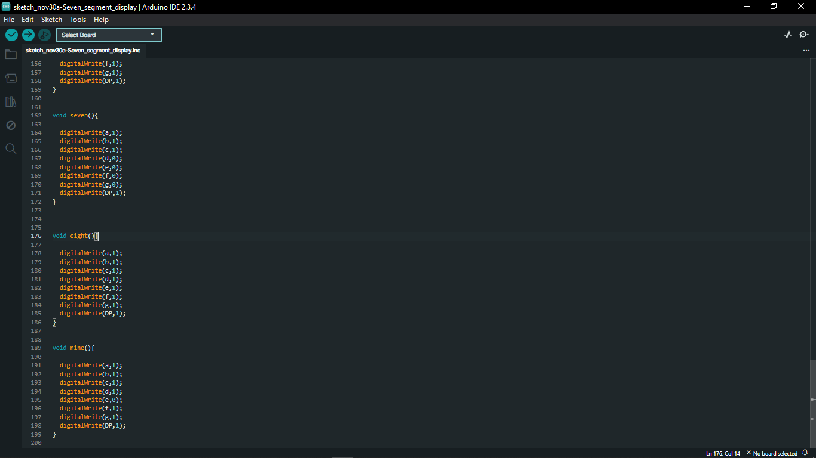

# 15. Combining Two Seven Segment Displays

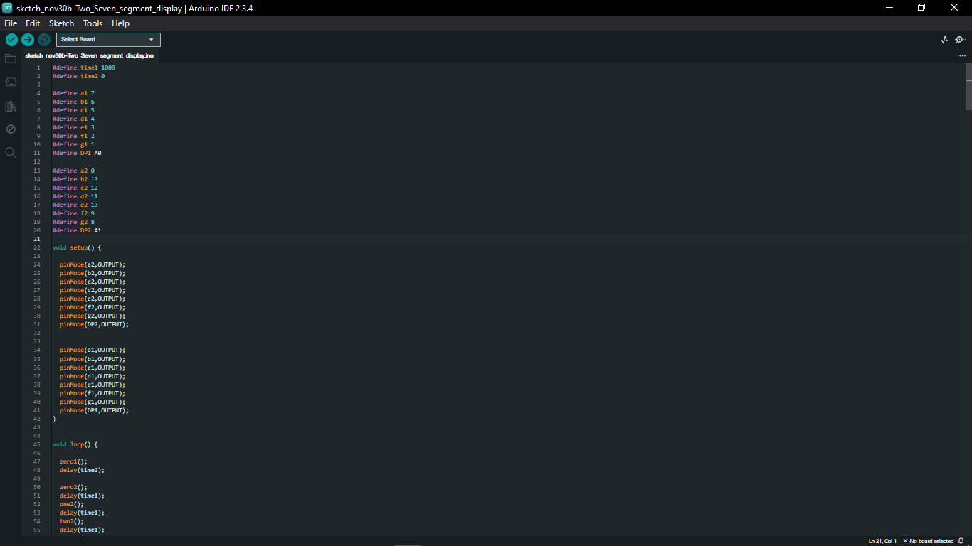

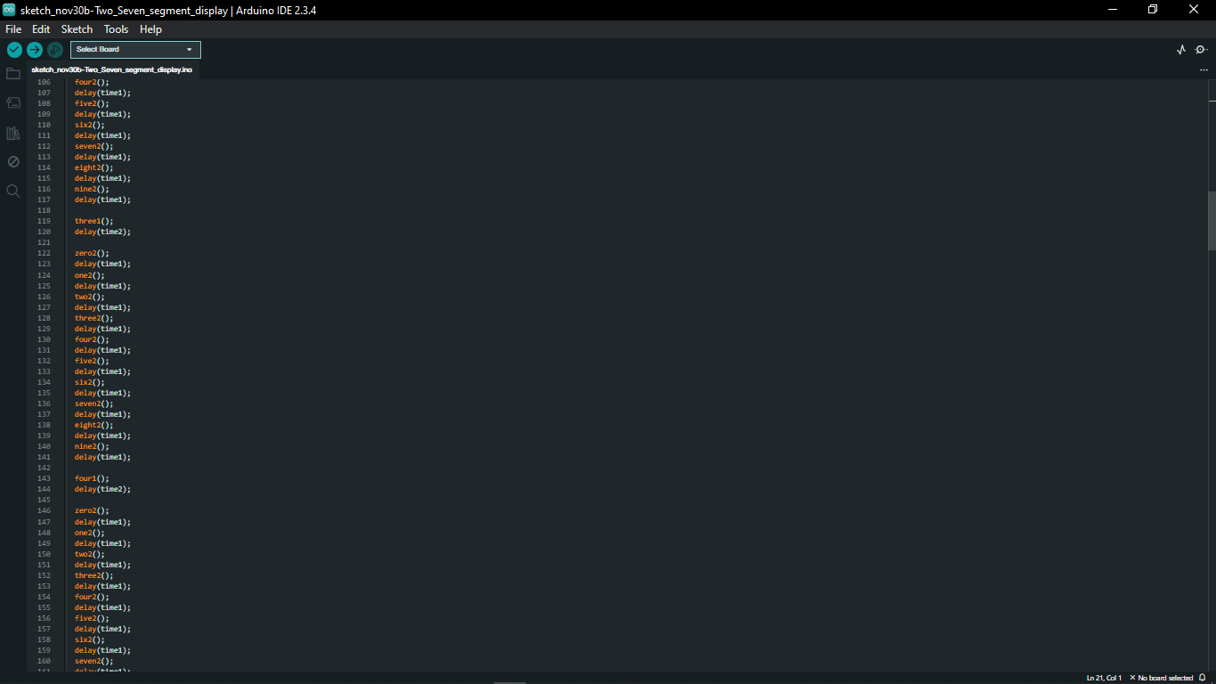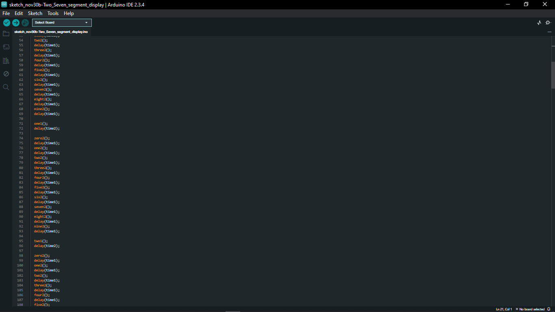

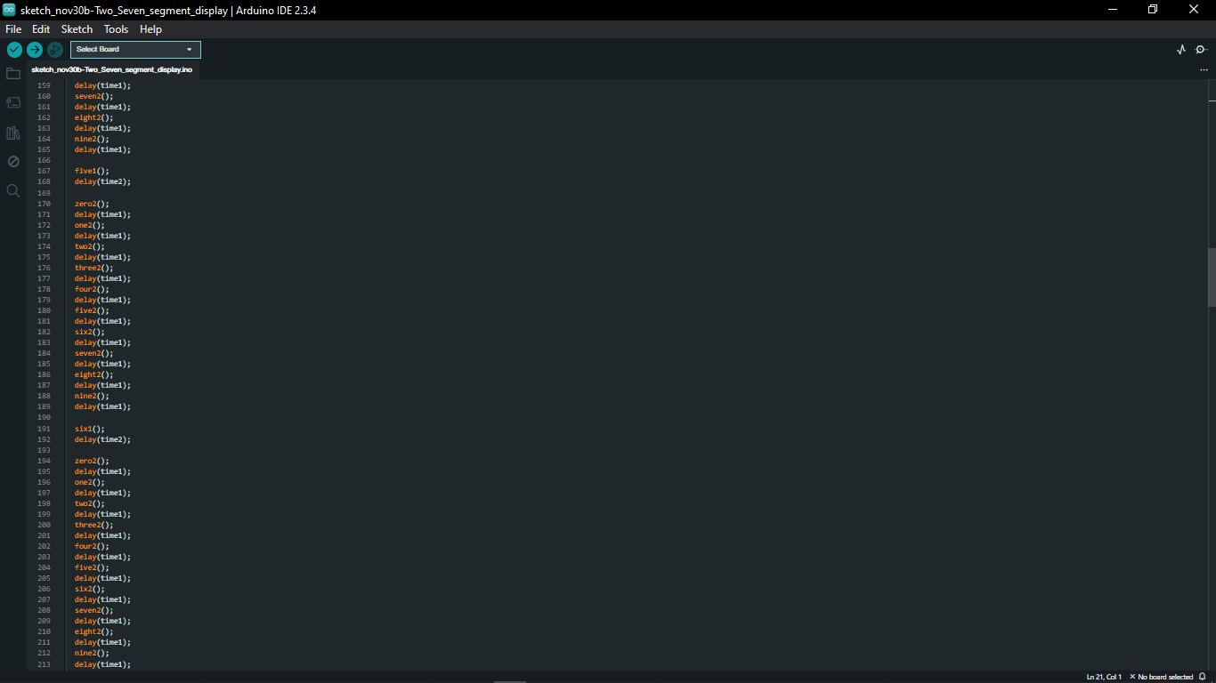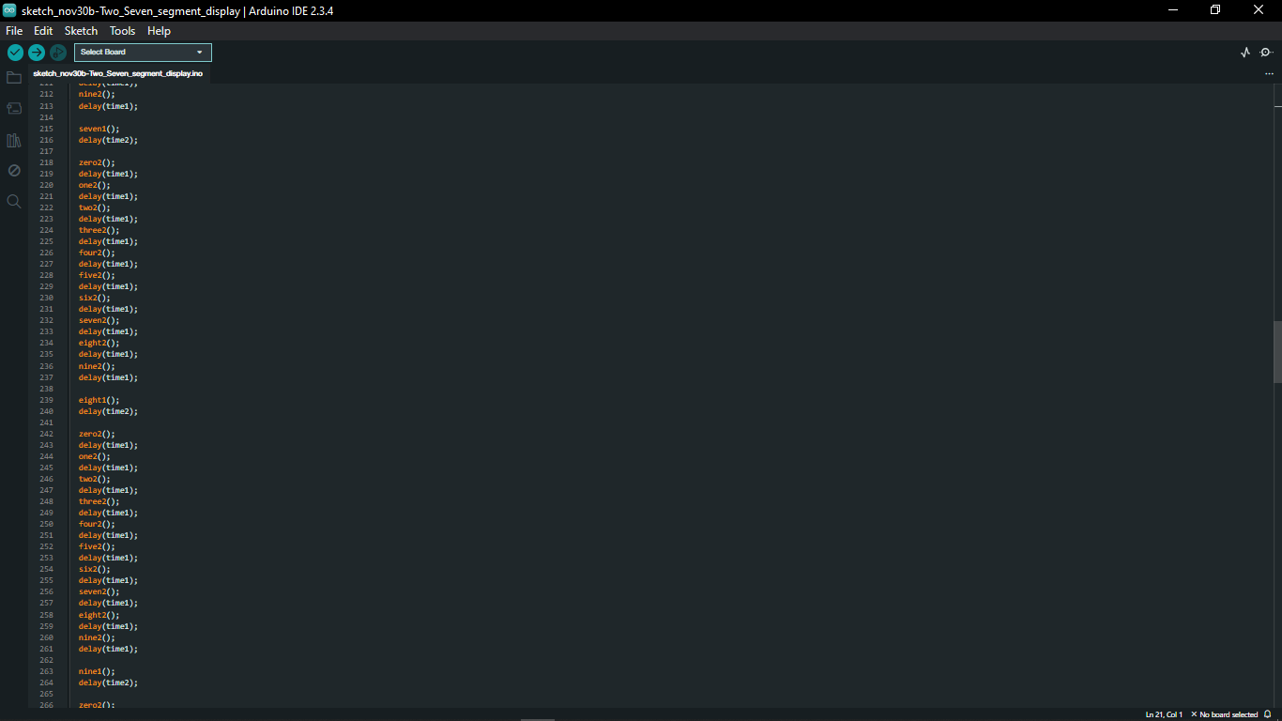

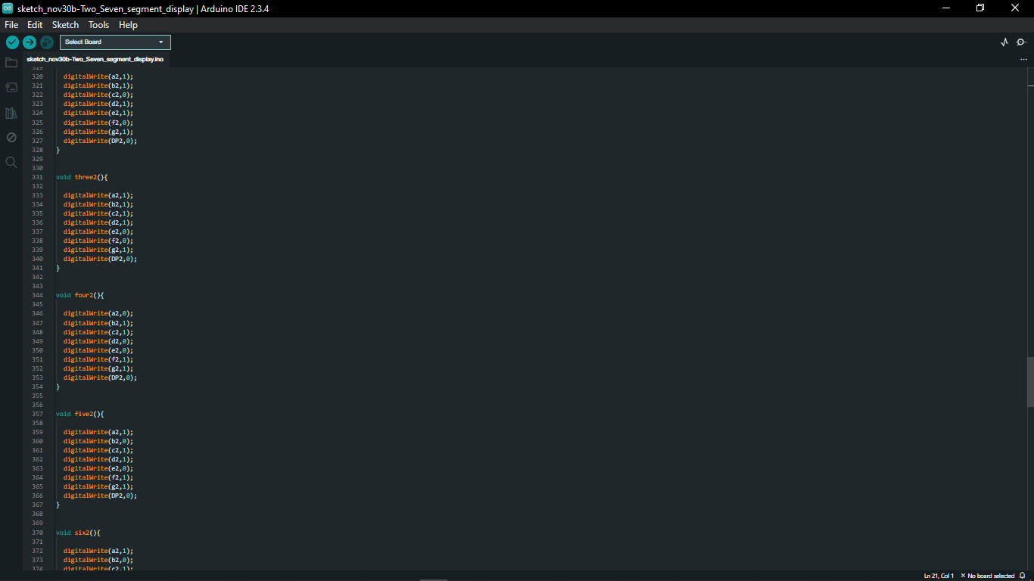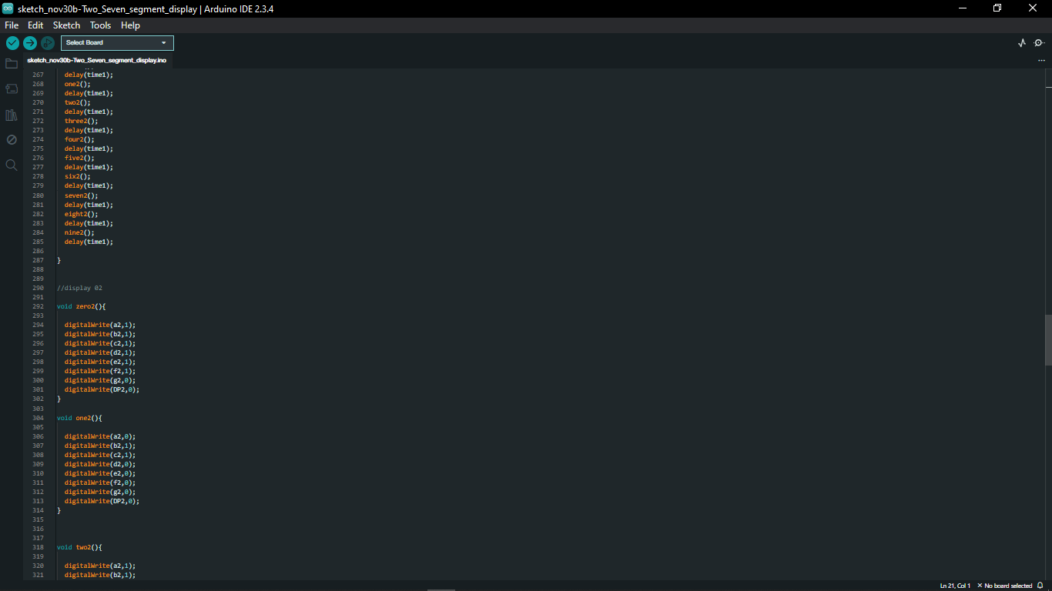

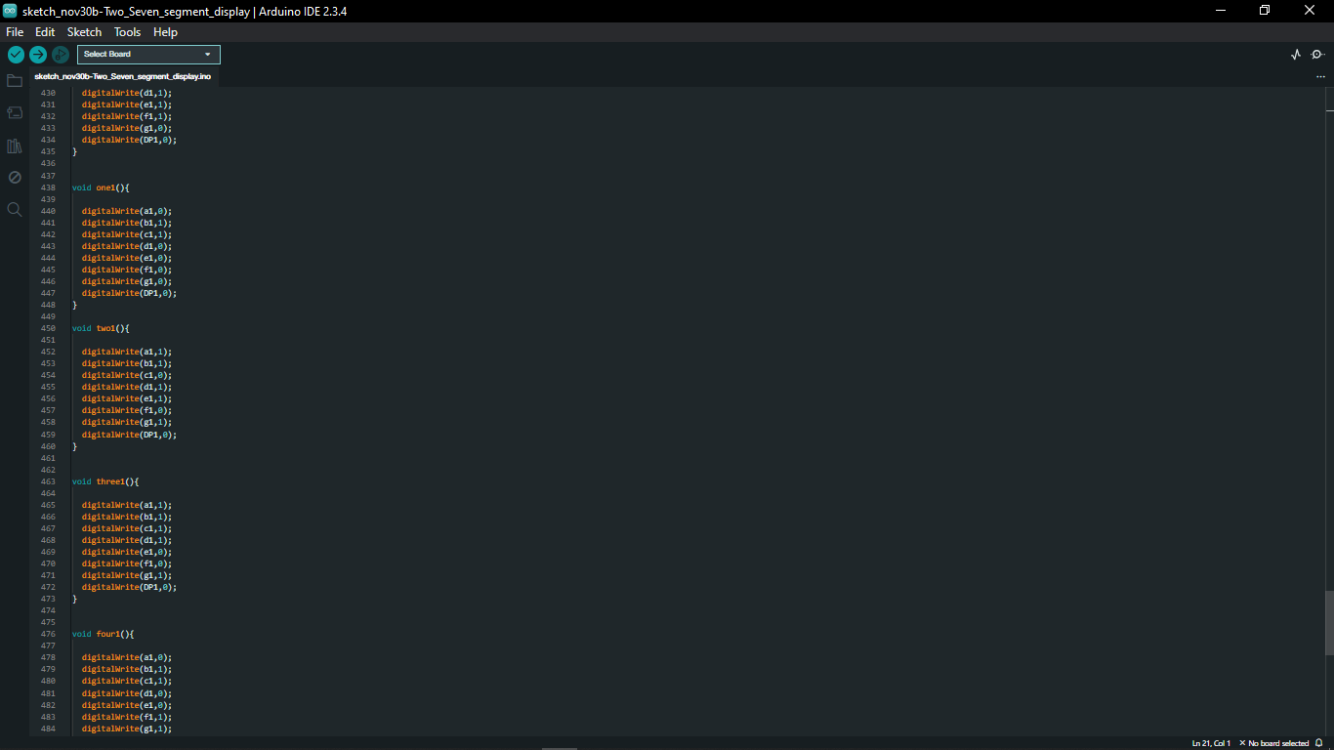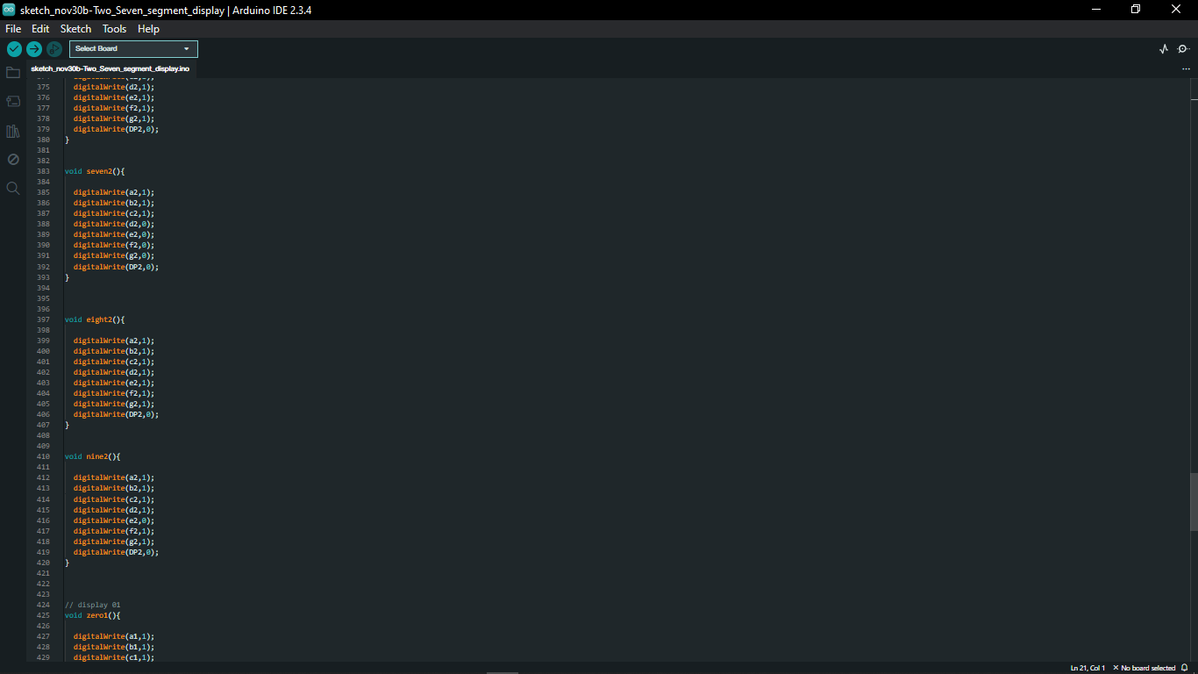

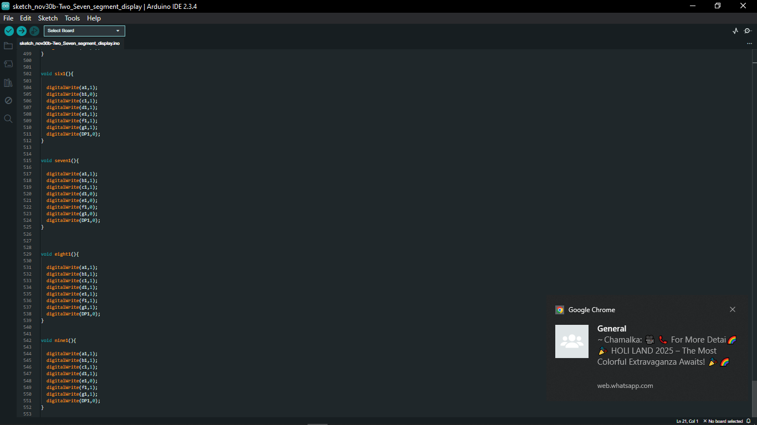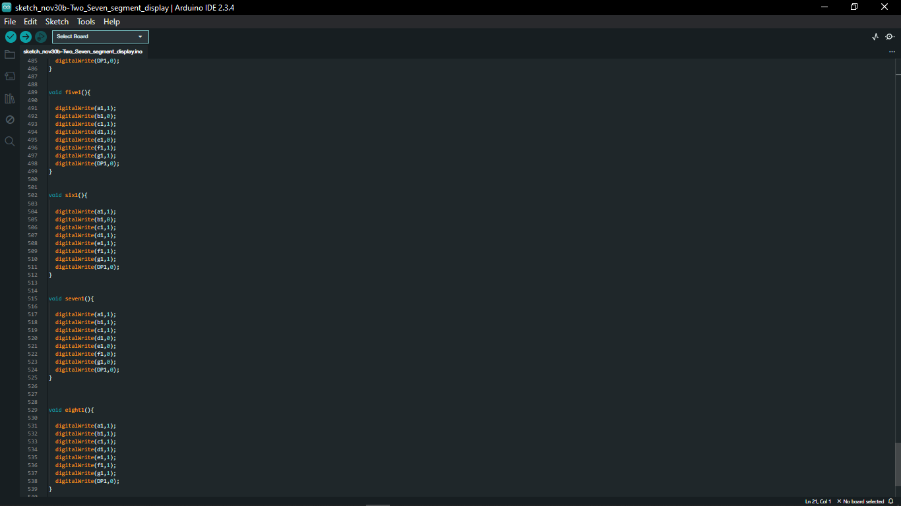

# 16. Joystick Module

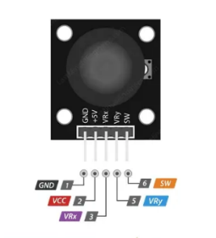

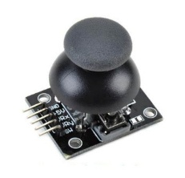

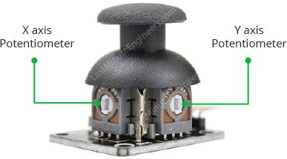

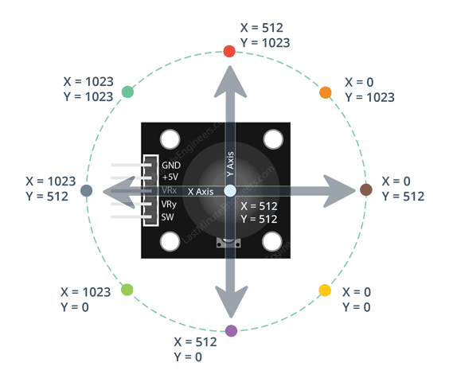

* The pinout for a Dual Axis XY Joystick Module typically includes five pins, arranged in a row or a column.

# 17. Control LED’s Brightness Using Joy Stick

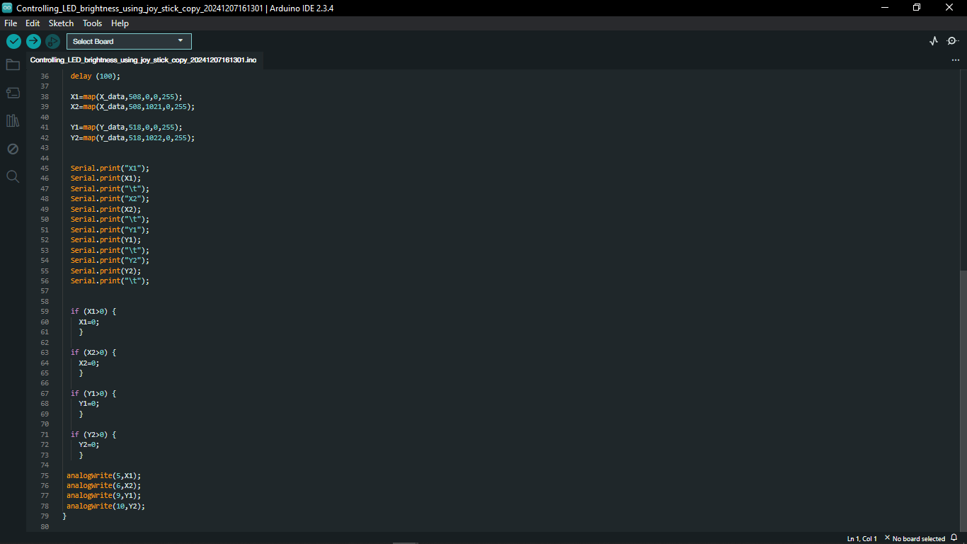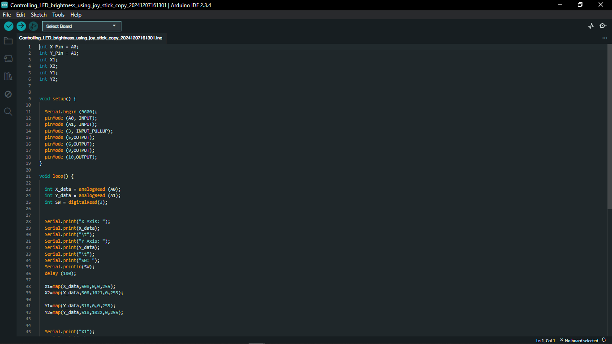

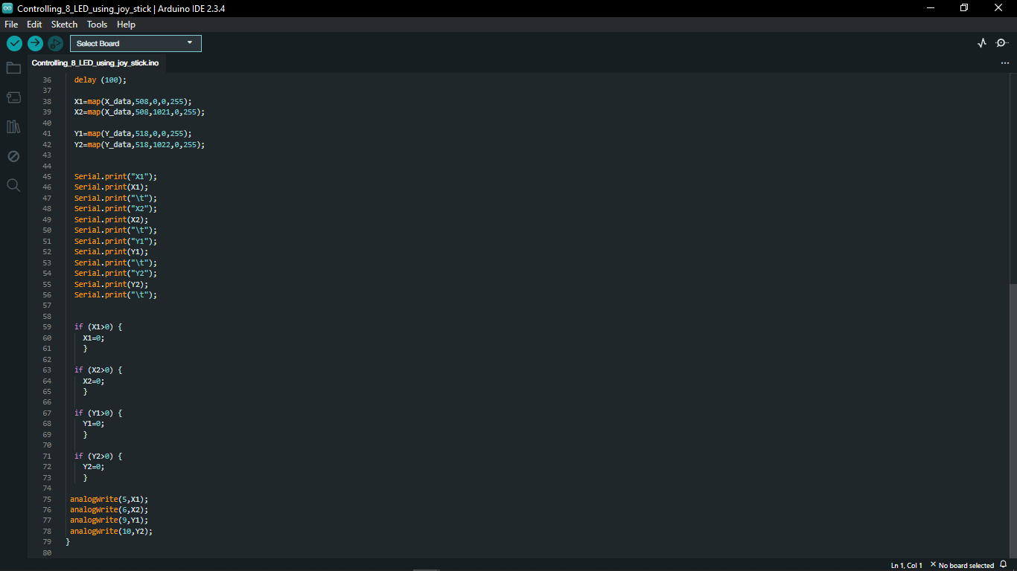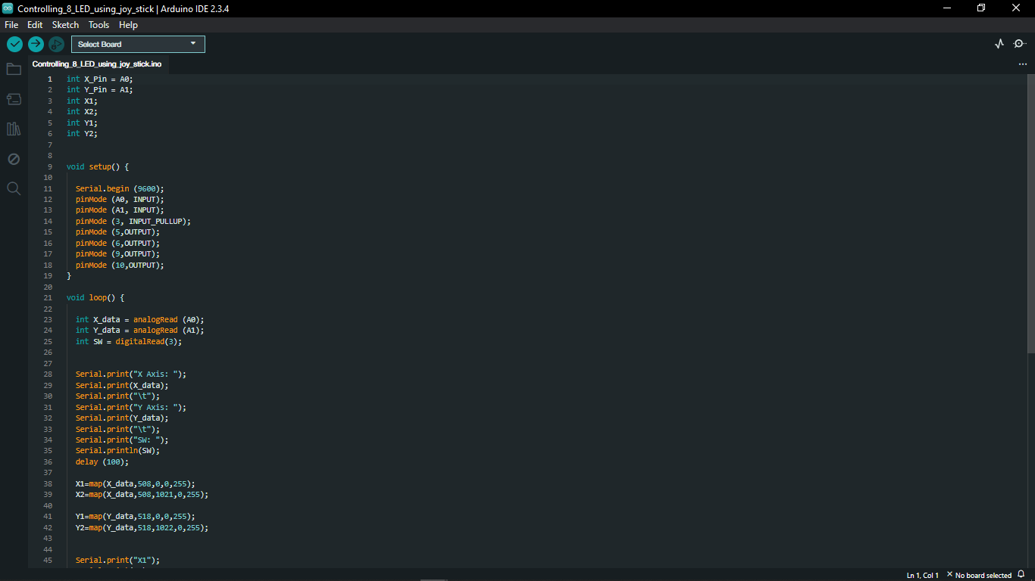

# 18. Pulse Width Modulation (PWM)

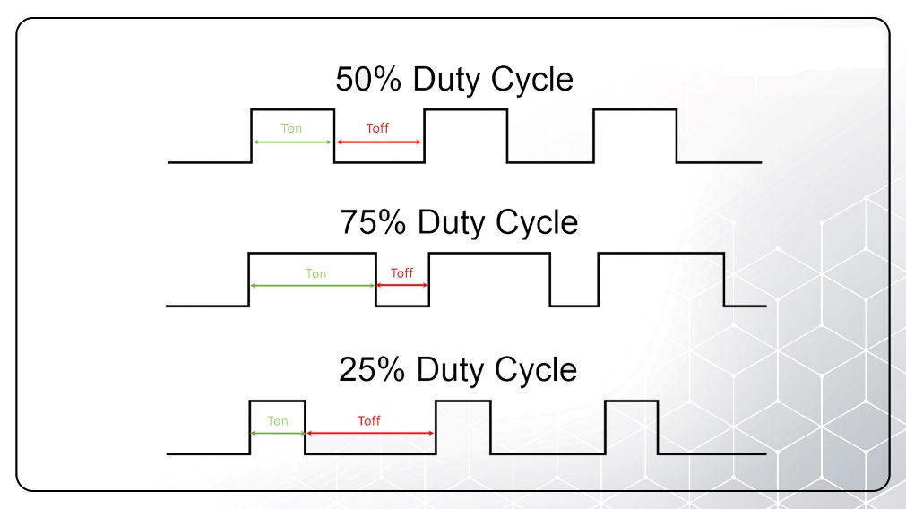

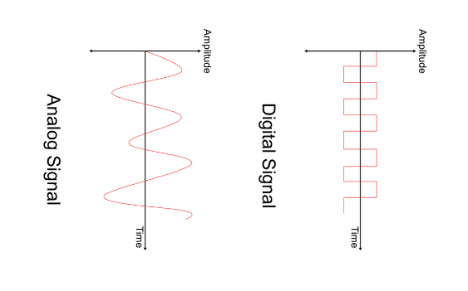

* PWM (Pulse Width Modulation) is a technique used to control the power delivered to electronic components by varying the duty cycle of a digital signal.
* It works by rapidly switching a signal ON and OFF at a fixed frequency, where the duty cycle (percentage of time the signal is HIGH) determines the effective output power.
* **Common Uses of PWM**
* Motor speed control (e.g., DC motors, servo motors)
* LED brightness control
* Voltage regulation (e.g., switching power supplies)

For example, in a PWM signal with a 50% duty cycle, the output is HIGH for half the time and LOW for the other half, resulting in half the power output.

# 19. Motor Driver L298N

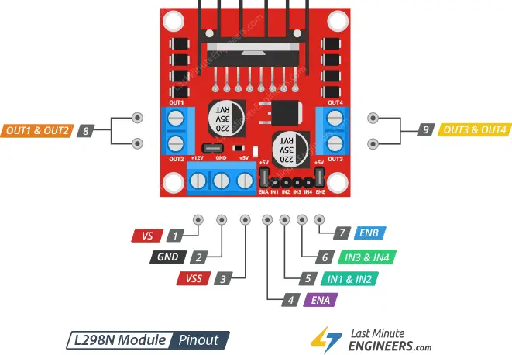

* The L298N is a motor driver IC designed to control the speed and direction of DC motors and stepper motors.
* It operates on the H-bridge principle, which allows the motor to rotate in both clockwise and counterclockwise directions by changing the polarity of the voltage applied to it.
* The L298N motor driver has a supply range of 5V to 35V and is capable of 2A continuous current per channel, so it works very well with most of our DC motors.

|  |  |
| --- | --- |
| Motor output voltage | 5V – 35V |
| Motor output voltage (Recommended) | 7V – 12V |
| Logic input voltage | 5V – 7V |
| Continuous current per channel | 2A |
| Max Power Dissipation | 25W |

* The L298N motor driver has two input power pins: VS and VSS.

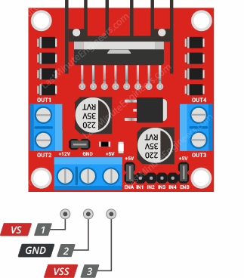

**VS -** pin powers the IC’s internal H-Bridge, which drives the motors. This pin accepts input voltages ranging from 5 to 12V.

**VSS -** is used to power the logic circuitry within the L298N IC, and can range between 5V and 7V.

**GND -** is the common ground pin.

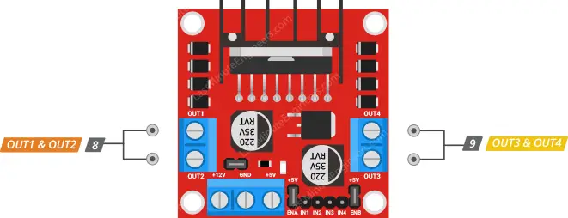

OUT1 and OUT2 for motor A and OUT3 and OUT4 for motor B.

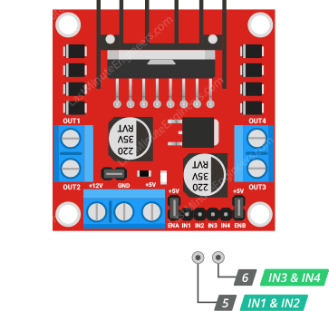

The module has two direction control pins. The IN1 and IN2 pins control the spinning direction of motor A; While IN3 and IN4 control the spinning direction of motor B.

# 20. Control Motor with Joy Stick Using L298N Motor Driver

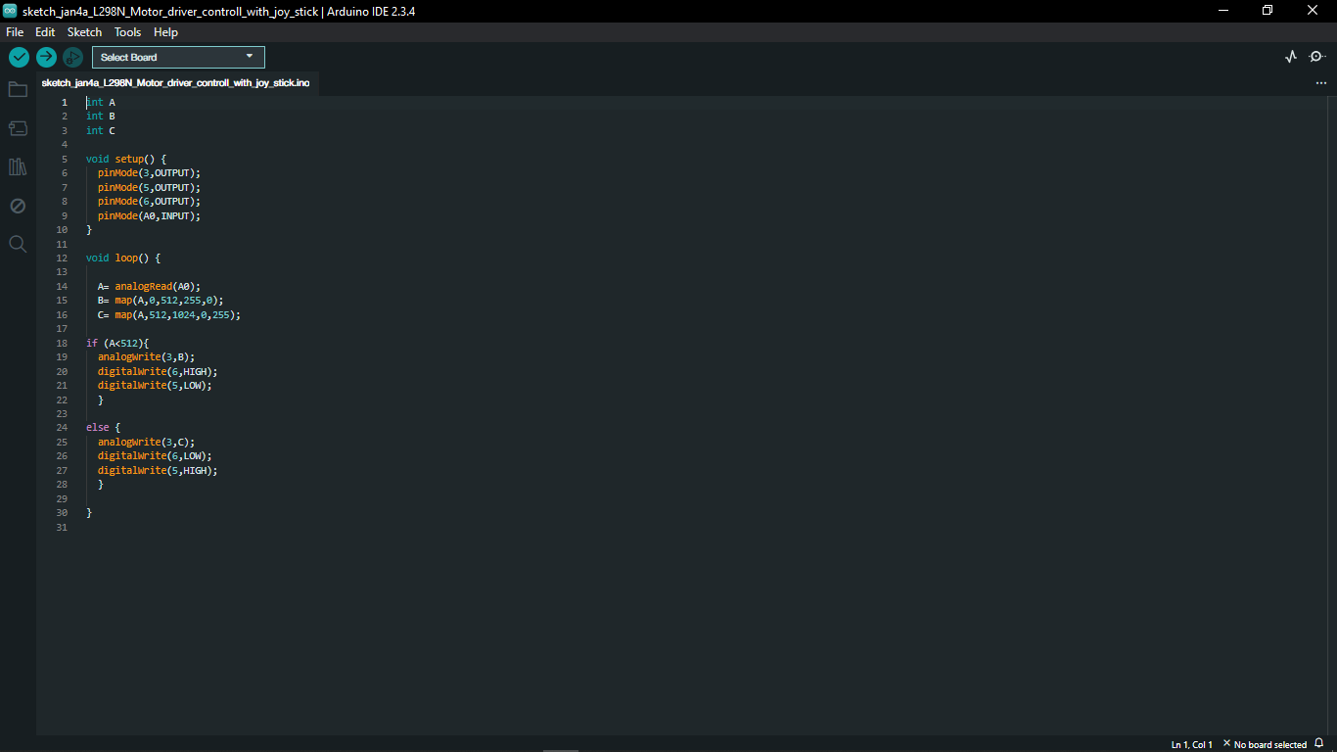

# 21. Control Motor Using Potentiometer

# 22. Control Speed of the Motor Using L298N Motor Driver

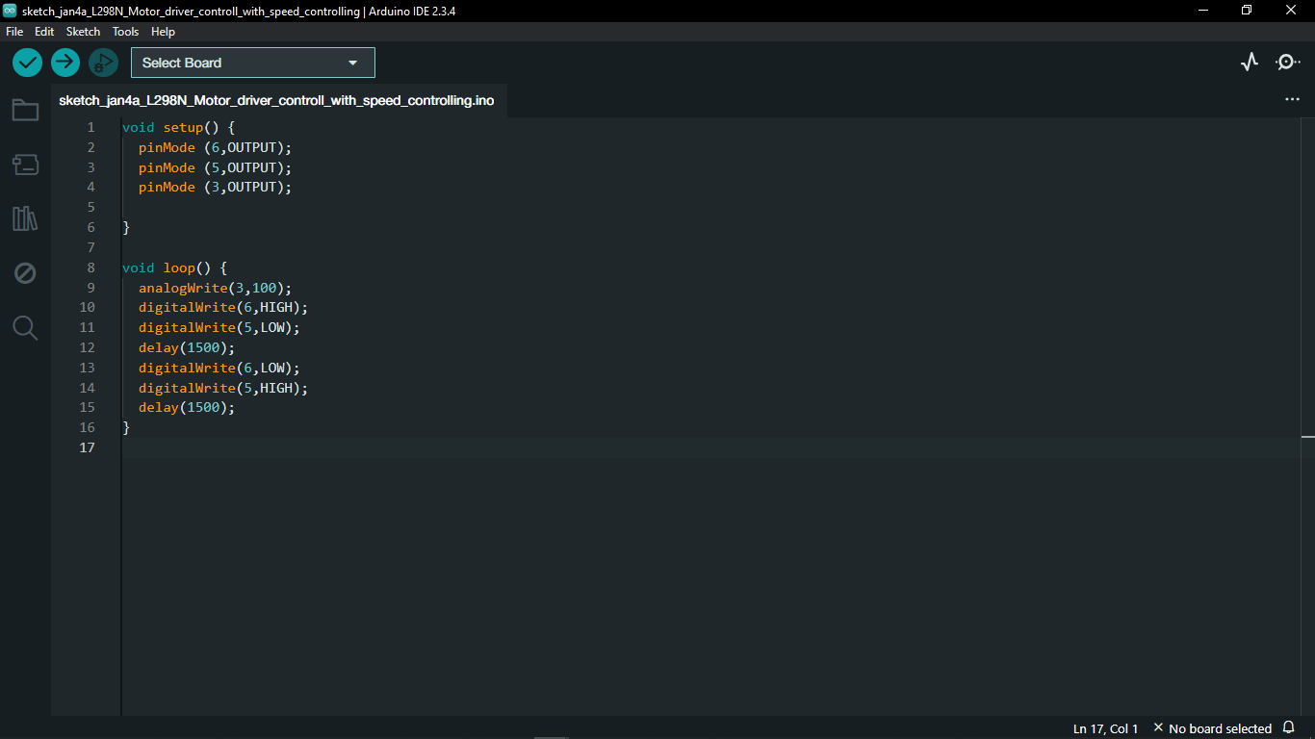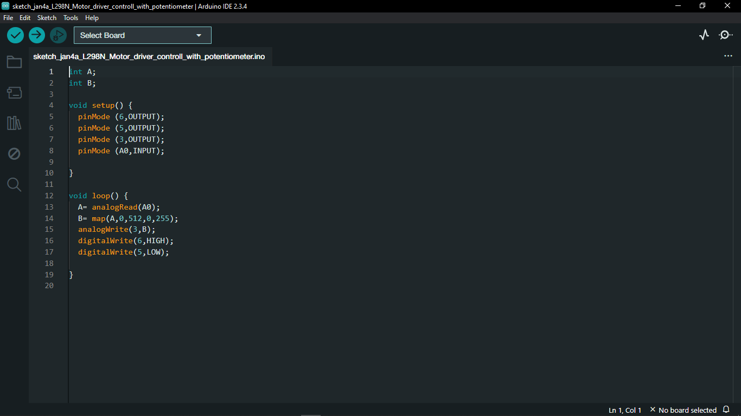

# 23. Control Simple Robot Car’s Two Motors

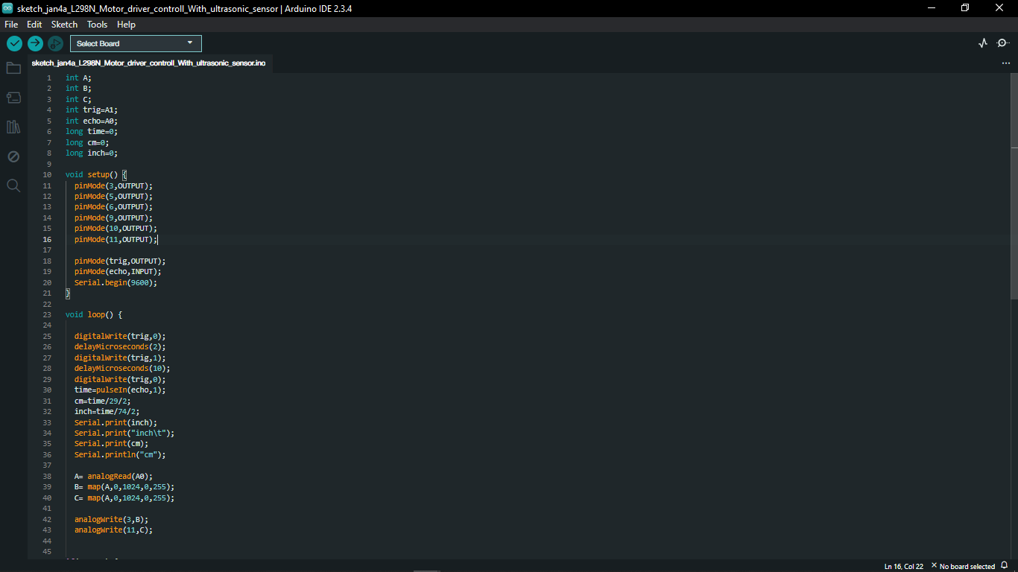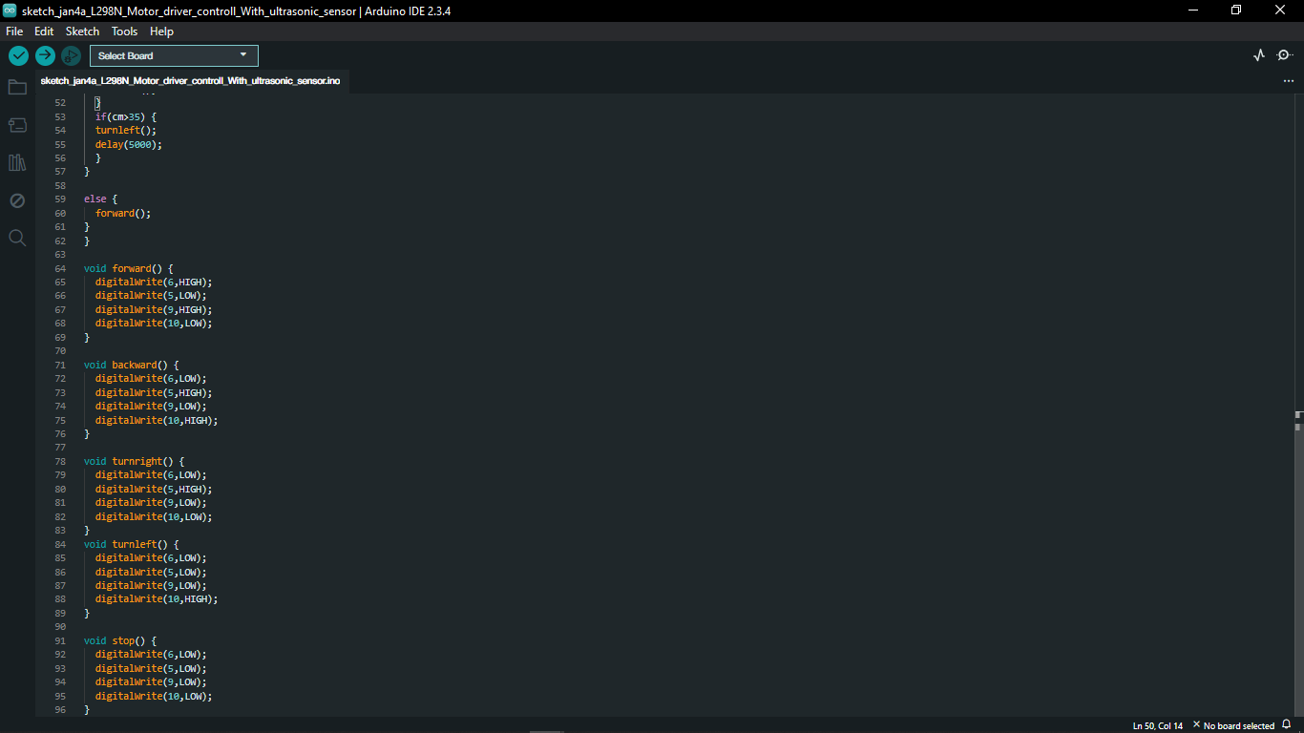

# 24. Data Types

## 24.1 byte

* A byte stores an 8-bit unsigned number, from 0 to 255.

|  |  |  |  |  |  |  |  |
| --- | --- | --- | --- | --- | --- | --- | --- |
| 0 | 1 | 2 | 3 | 4 | 5 | 6 | 7 |

bit

## 24.2. int

* Integers are primary data-type for number storage.
* On the Arduino UNO (and other ATmega based boards) an int stores a 16-bit (2-byte) value. This yields a range of -32,768 to 32,767 (minimum value of -215 and a maximum value of (215) - 1).

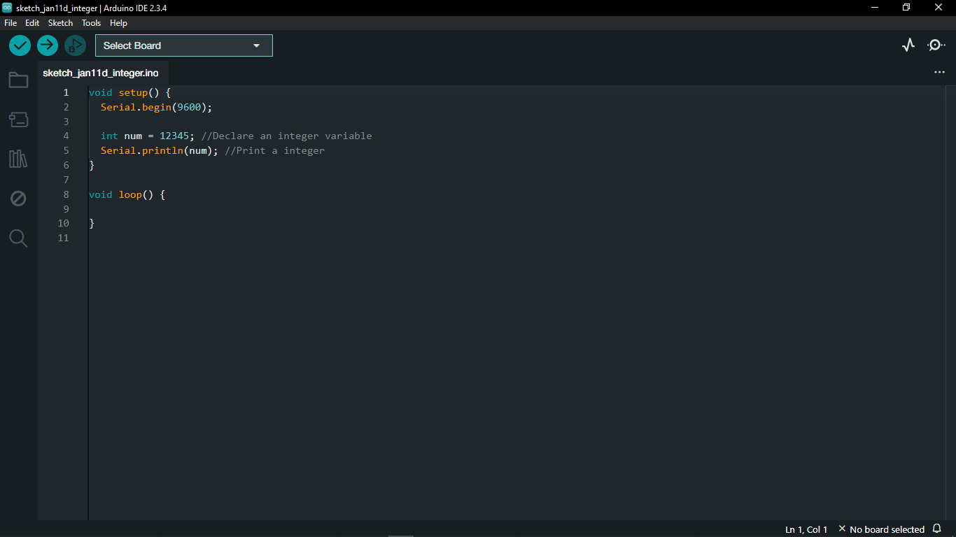

## 24.3. long

* Long variables are extended size variables for number storage, and store 32 bits (4 bytes), from -2,147,483,648 to 2,147,483,647.
* If doing math with integers at least one of the values must be of type long.

## 24.4. float

* Datatype for floating-point numbers, a number that has a decimal point.
* Floating-point numbers are often used to approximate analog and continuous values because they have greater resolution than integers.
* Floating-point numbers can be as large as 3.4028235E+38 and as low as -3.4028235E+38.
* They are stored as 32 bits (4 bytes) of information.

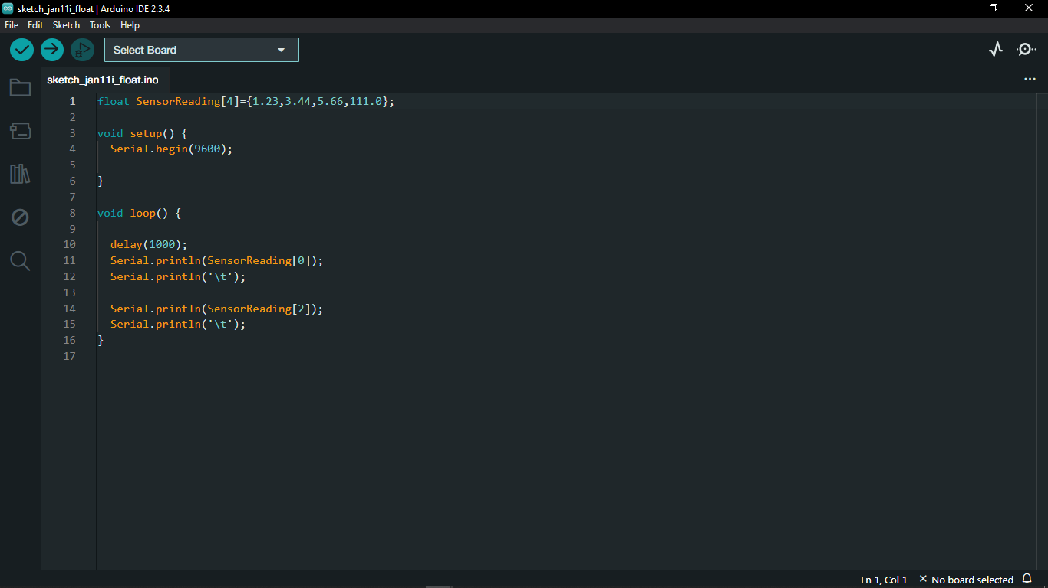

## 24.5. bool

* A bool holds one of two values, true or false. (Each bool variable occupies one byte of memory.)

## 24.6. double

* Double precision floating point number.
* On the UNO and other ATMEGA based boards, this occupies 4 bytes.
* That is, the double implementation is exactly the same as the float, with no gain in precision.
* On the Arduino Due, doubles have 8-byte (64 bit) precision.

## 24.7. char

* A data type used to store a character value. Character literals are written in single quotes, like this: ‘A’ (for multiple characters use - strings -).
* The size of the char datatype is at least 8 bits. It’s recommended to only use char for storing characters.
* For an unsigned, one-byte (8 bit) data type, use the byte data type.
* Stores a single character or a small number (1 byte )

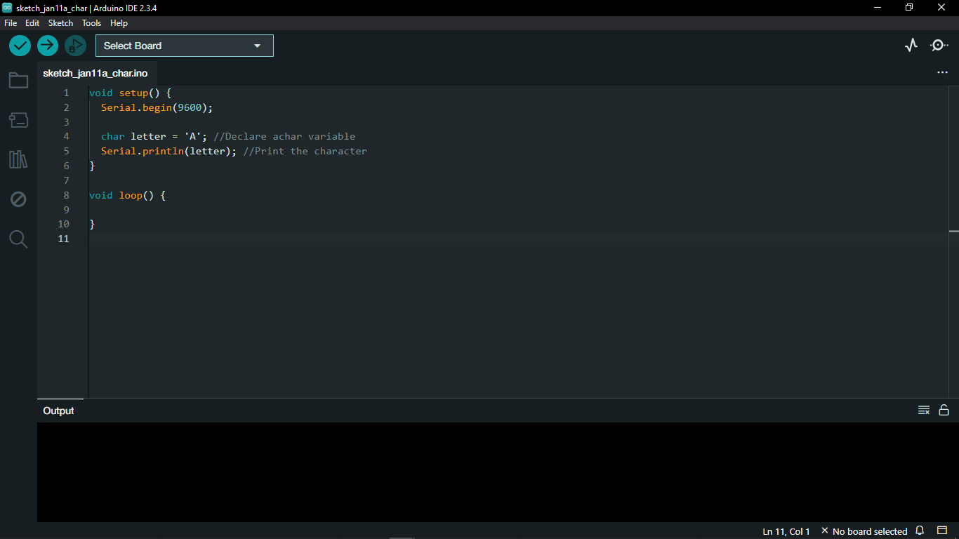

## 24.8. string

* Text strings can be represented in two ways. Can use the String data type, or can make a string out of an array of type char and null-terminate it.
* Strings are always defined inside double quotes ("Abc") and characters are always defined inside single quotes(A).

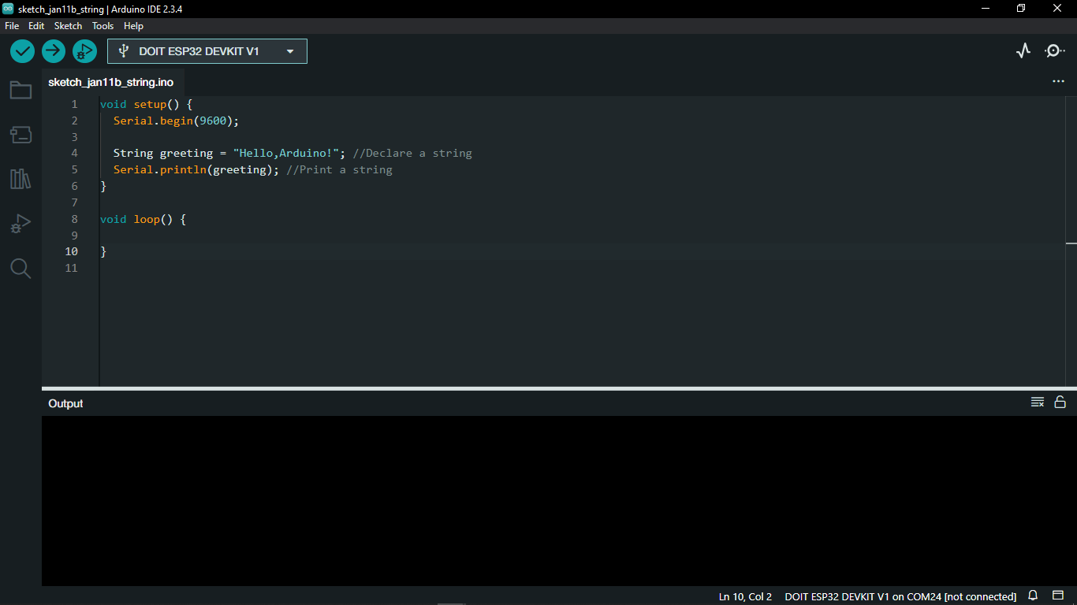

## 24.9. Array

* An array is a collection of variables that are accessed with an index number.
* Arrays in the C++ programming language Arduino sketches are written in can be complicated, but using simple arrays is relatively straightforward.
* All of the methods below are valid ways to create (declare) an array.

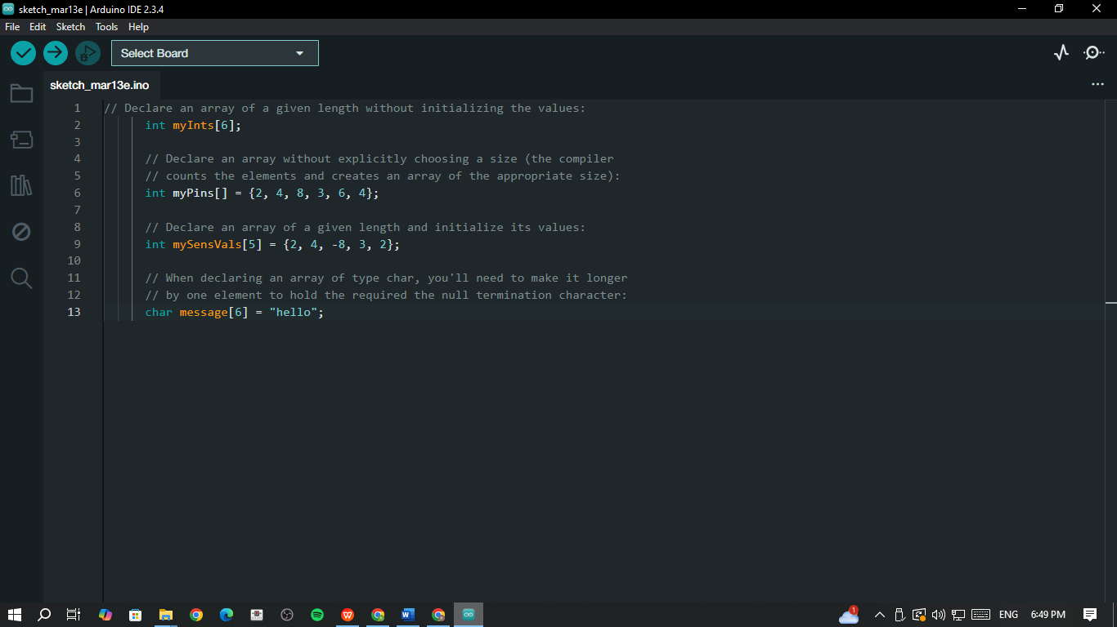

**24.10.** Addition  **24.11.** Subtraction

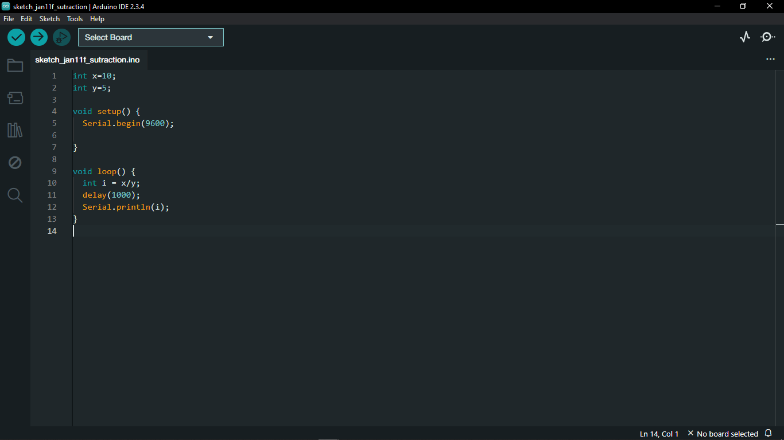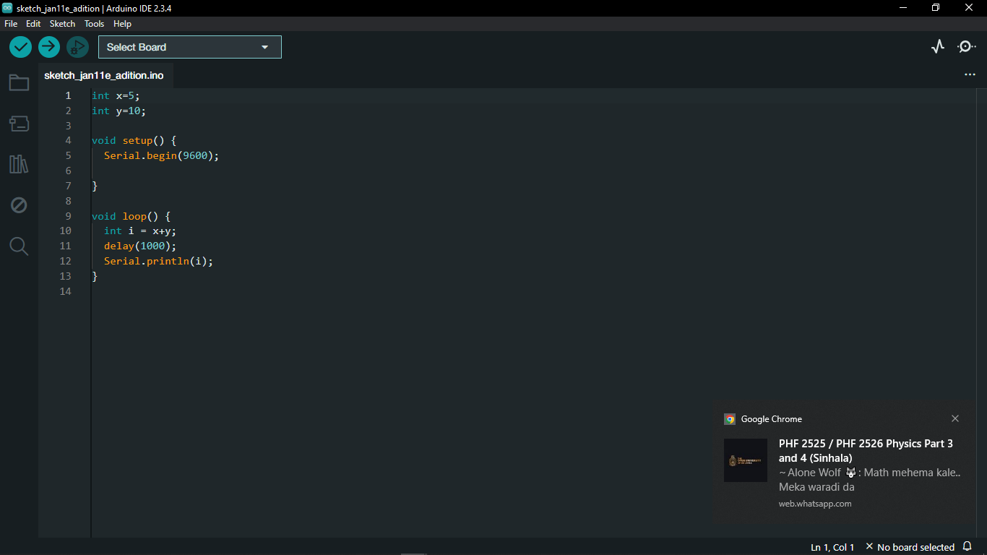

**24.12.** Multiplication **24.13.** Division

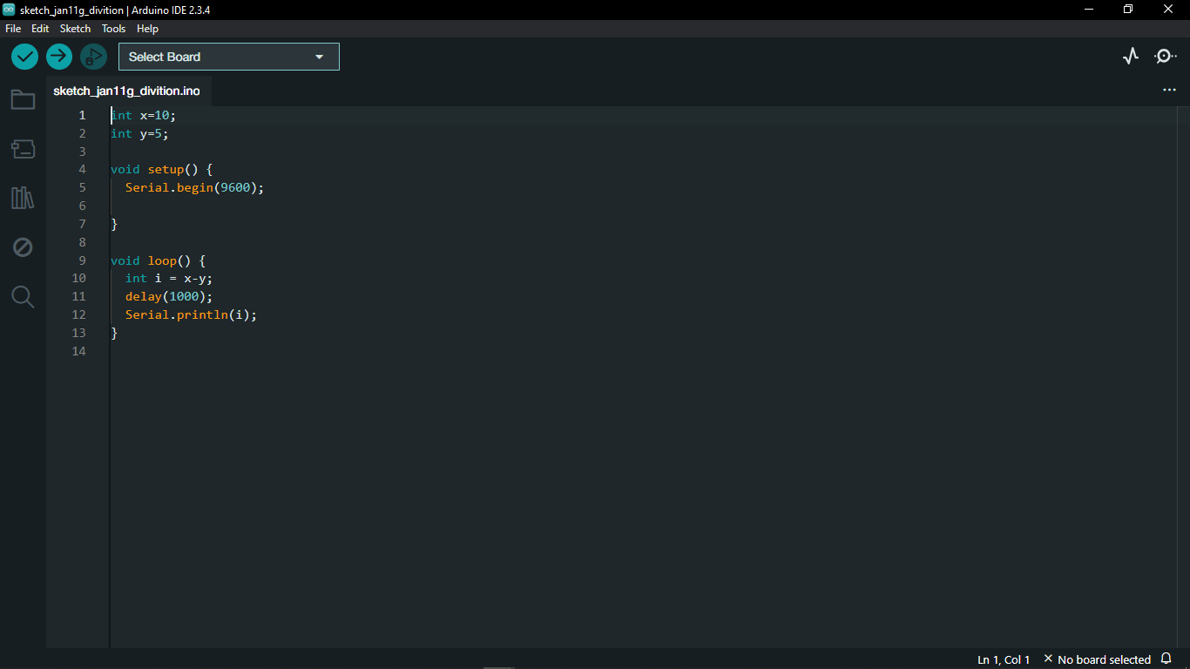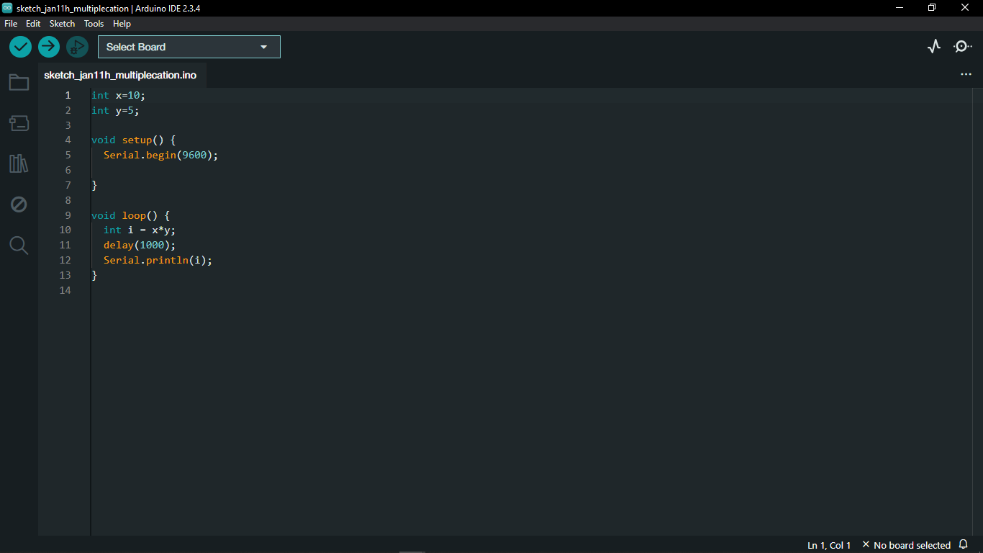

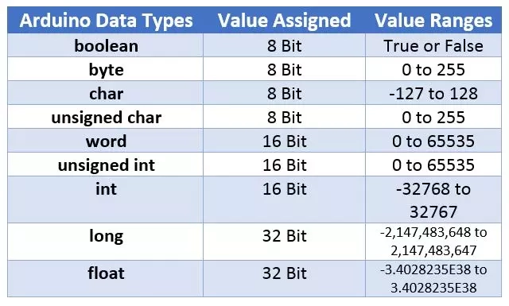

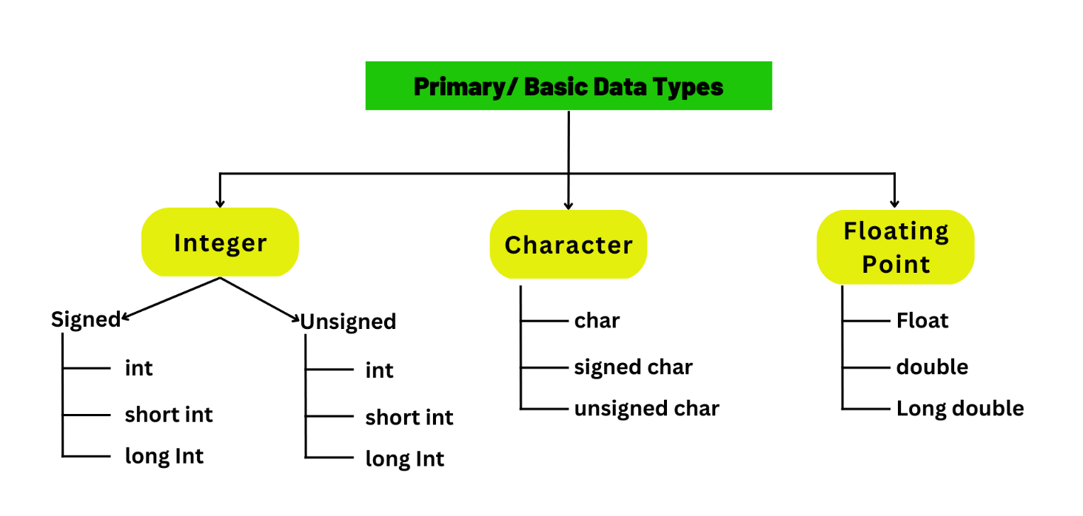

# 25. Servo Motor

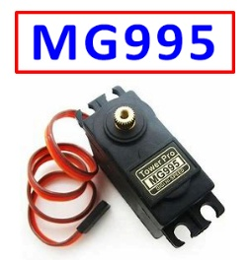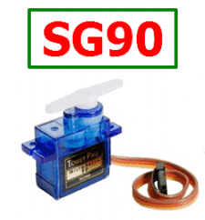

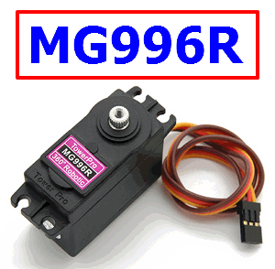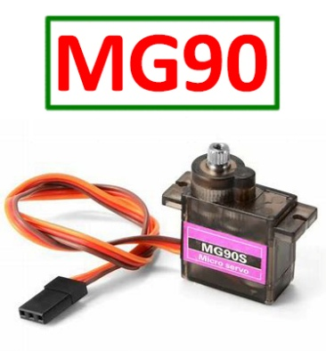

* A servo motor is a type of electric motor that can rotate or move to a specific position, speed, or torque based on an input signal from a controller.

# 26. Servo Motor

# 27. Servo Motor with Potentiometer

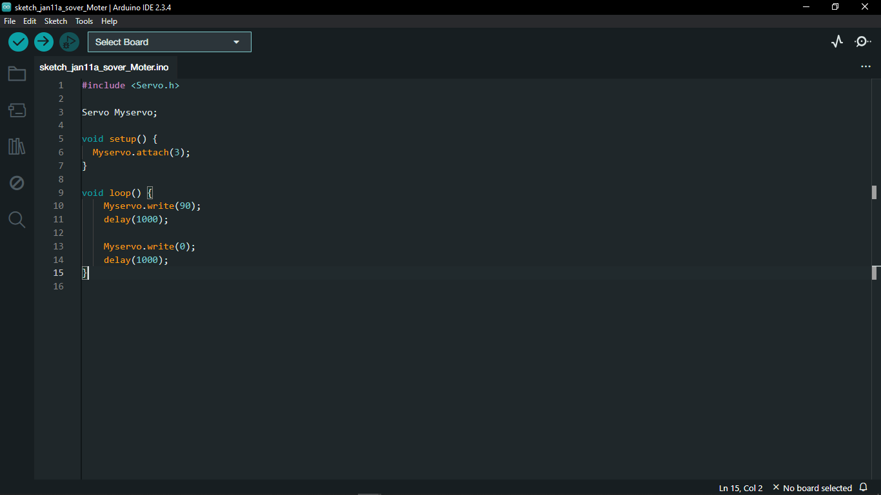

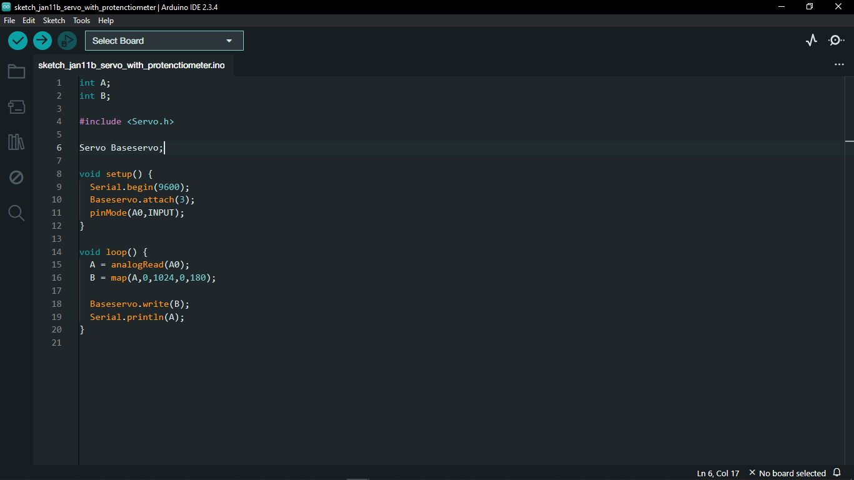

# 28. Servo Motor with Push Button

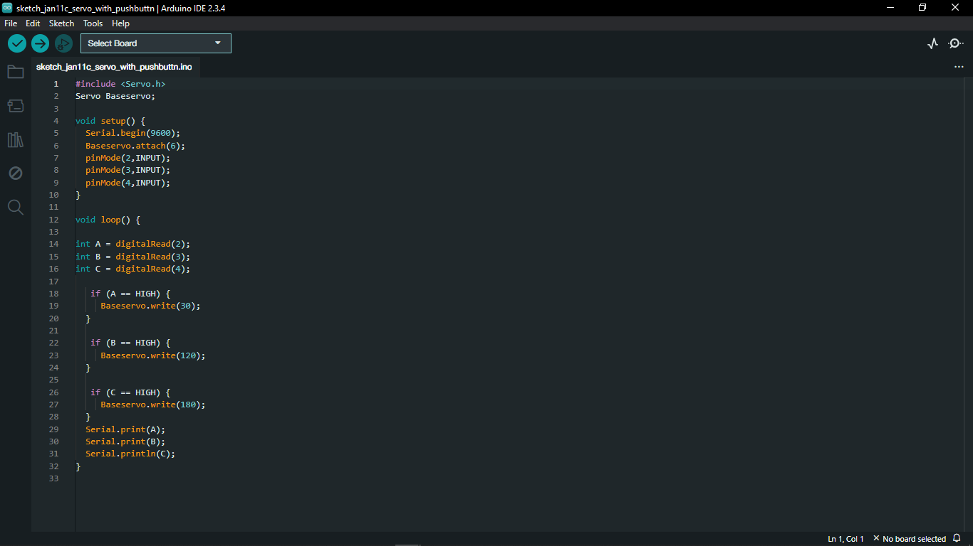

# 29. Relay Module

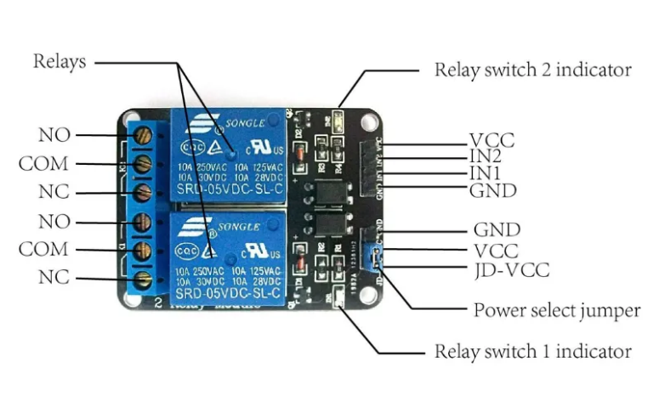

* A relay module is an electrically operated switch that allows a low-voltage signal (like from an Arduino or ESP32) to control a high-voltage circuit (AC or DC devices).

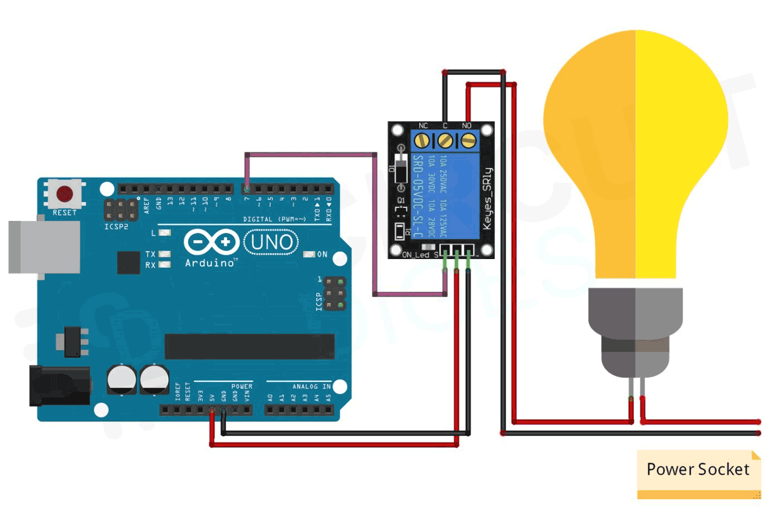

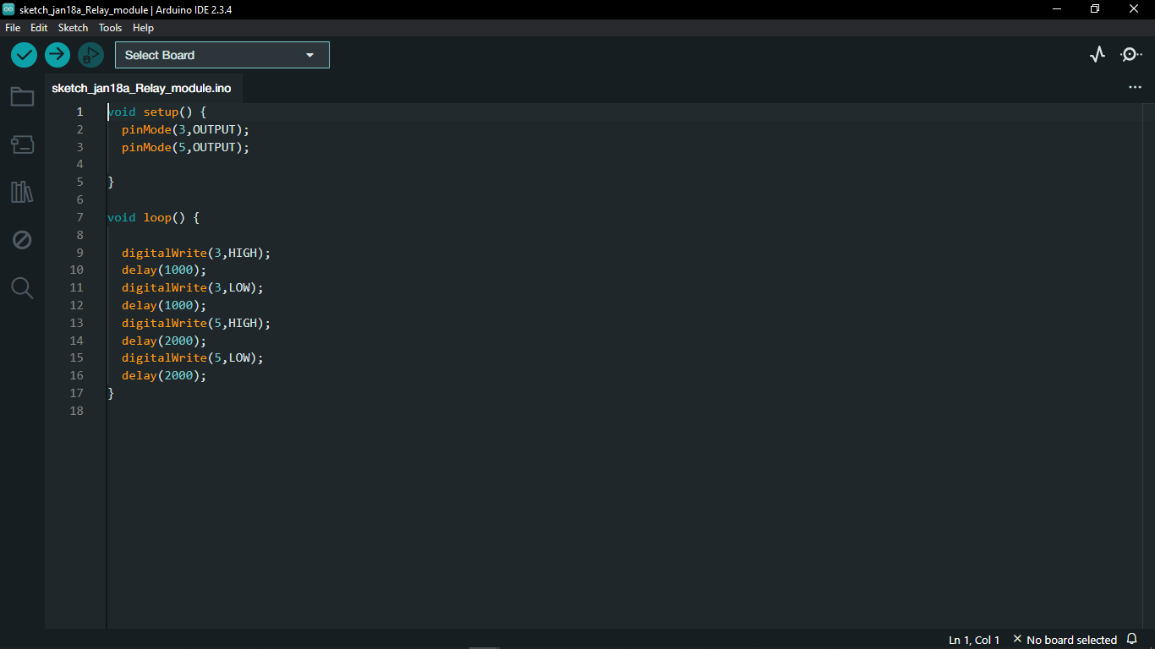

# 30. LDR Sensor Module

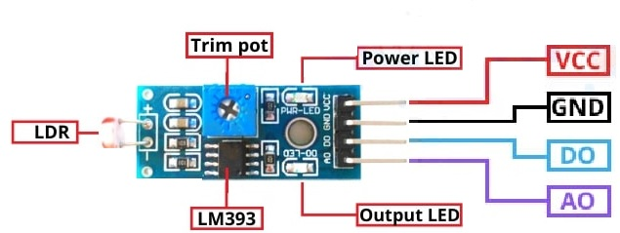

* An LDR (Light Dependent Resistor) module is a sensor that detects light intensity. The resistance of the LDR changes based on light levels:
* Bright light → Low resistance (high voltage output)
* Darkness → High resistance (low voltage output)
* Used in automatic lighting systems, solar trackers, and alarms.
* Outputs analog or digital signals depending on the module.

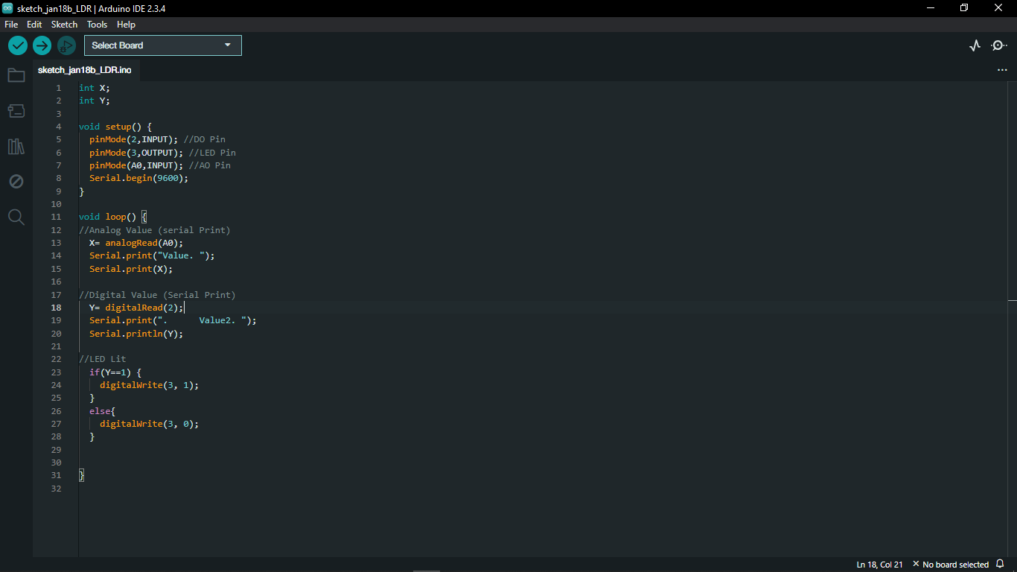

# 31. IR Sensor Module

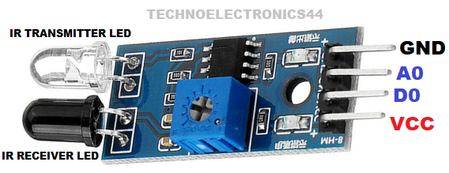

* An IR (Infrared) sensor module detects objects, motion, or heat using infrared light. It consists of an IR LED (emitter) and an IR receiver (photodiode or phototransistor).
* Types of IR Sensor Modules
* Obstacle Avoidance Sensor – Reflects IR light off objects to detect proximity.
* PIR (Passive Infrared) Sensor – Detects body heat/motion (used in security systems).
* 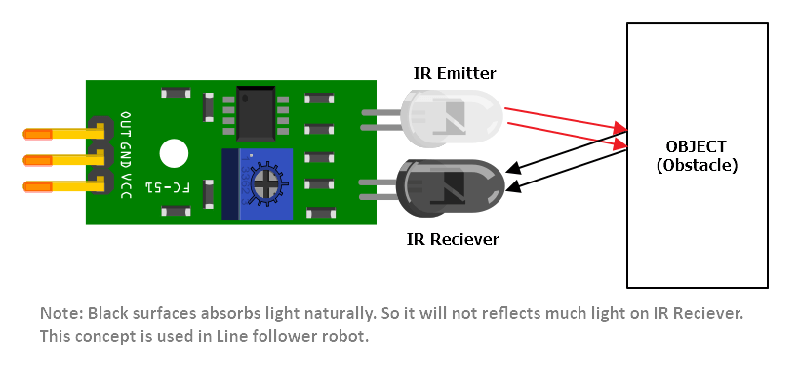IR Remote Receiver – Decodes IR signals from remotes (e.g., TVs, ACs)

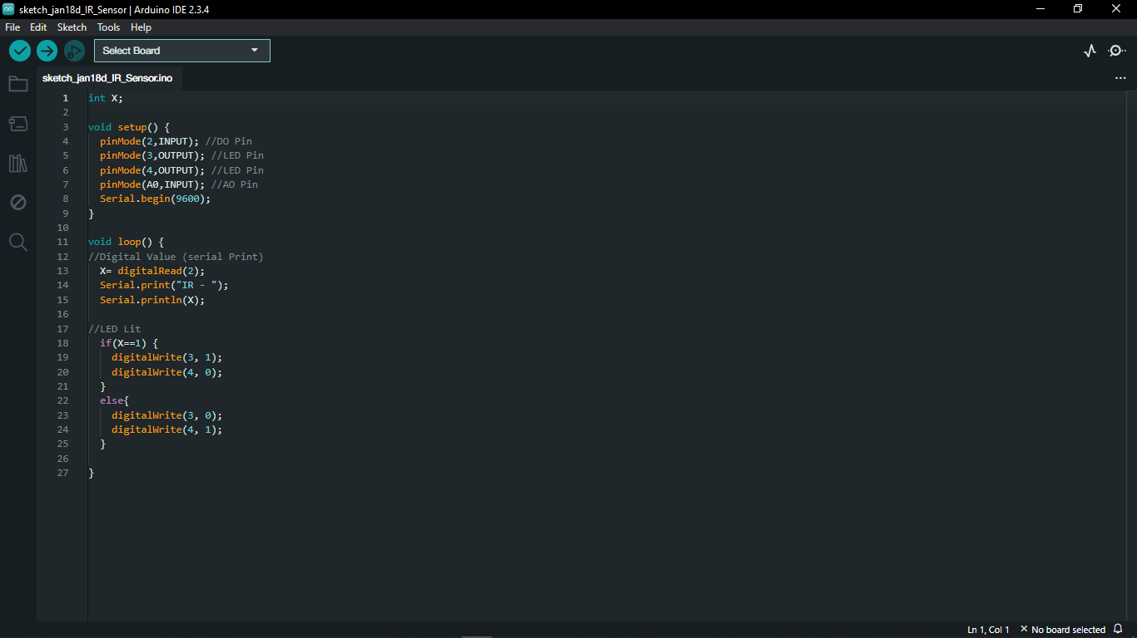

# 32. Key Pad

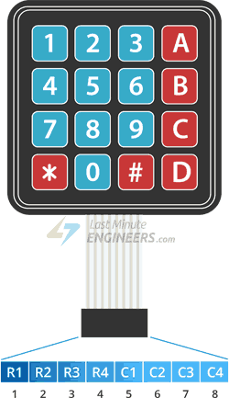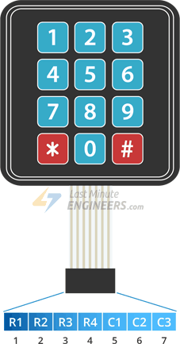

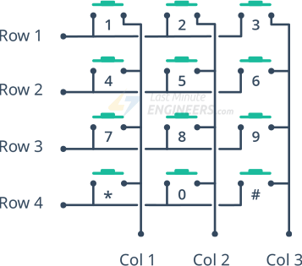



* R-> Rows
* C-> Columns
* A keypad for Arduino is an input device used to capture numerical or alphanumeric inputs. It consists of a matrix of buttons arranged in rows and columns, typically 4x3 (12 keys) or 4x4 (16 keys).
* Each button press connects a row and a column. The Arduino reads the key press by scanning row-column connections.
* Requires the Keypad library for easy interfacing.

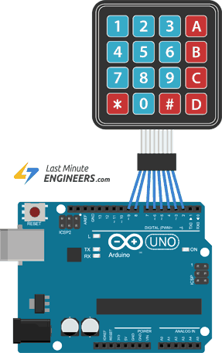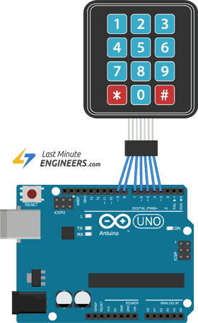

# 33. Key Pad with Password

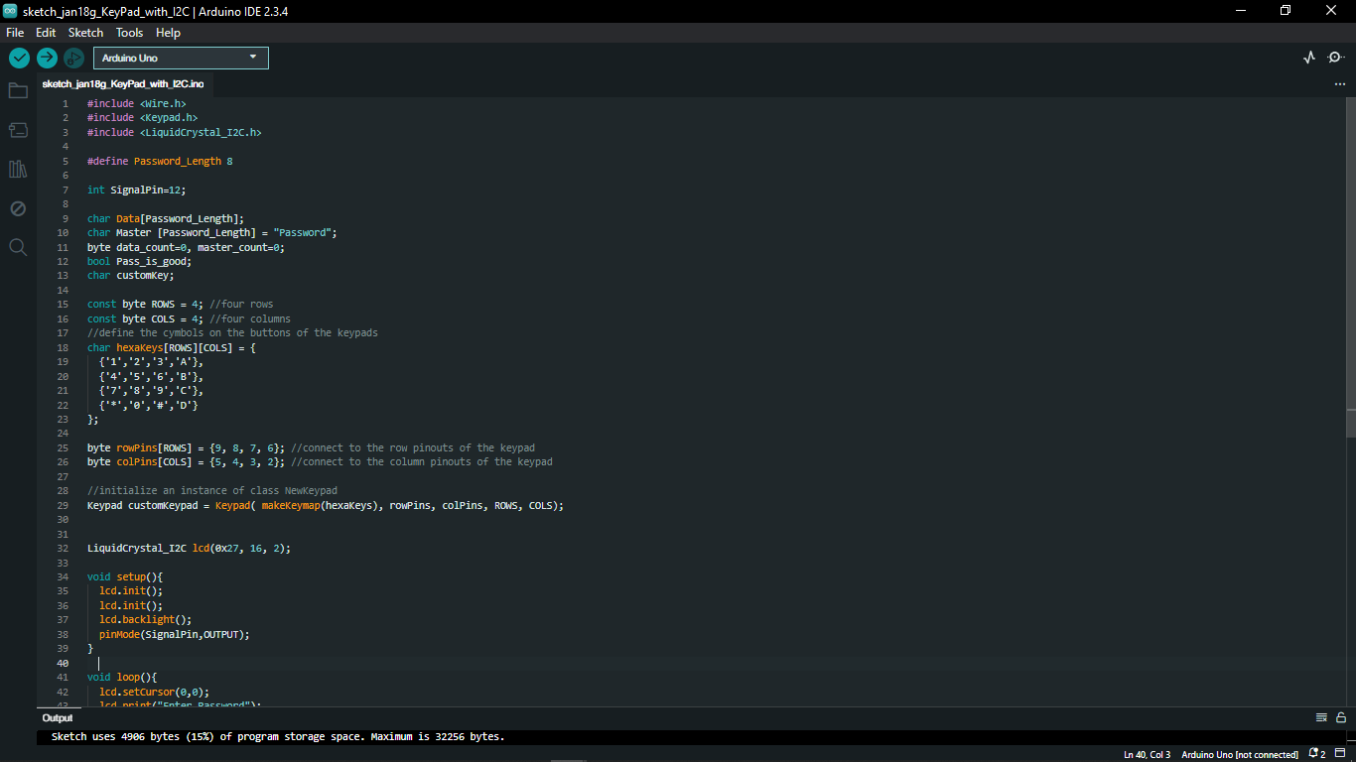

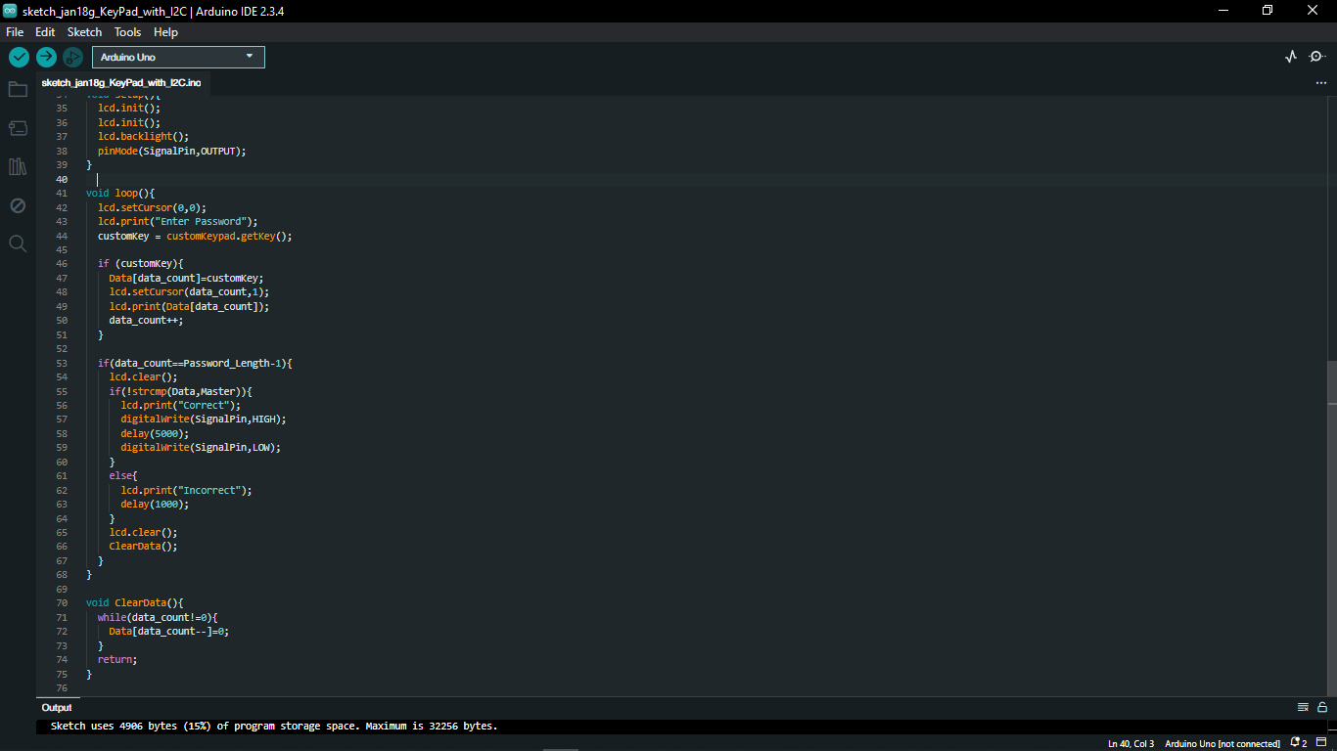

# 34. DHT22/11 Temperature and Humidity Sensor

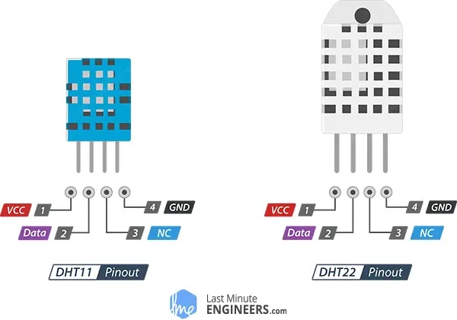

The **DHT11** and **DHT22** are digital sensors used for measuring **temperature and humidity**. They communicate using a **single-wire protocol** and are commonly used in weather stations, home automation, and IoT projects.

|  |  |  |
| --- | --- | --- |
|  | DHT11 | DHT22 |
| Operating Voltage | 3 to 5V | 3 to 5V |
| Max Operating Current | 2.5mA max | 2.5mA max |
| Humidity Range | 20-80% / 5% | 0-100% / 2-5% |
| Temperature Range | 0-50°C / ± 2°C | -40 to 80°C / ± 0.5°C |
| Sampling Rate | 1 Hz (reading every second) | 0.5 Hz (reading every 2 seconds) |
| Advantage | Ultra-low cost | More Accurate |

# 35. DHT22 Sensor with I2C Display

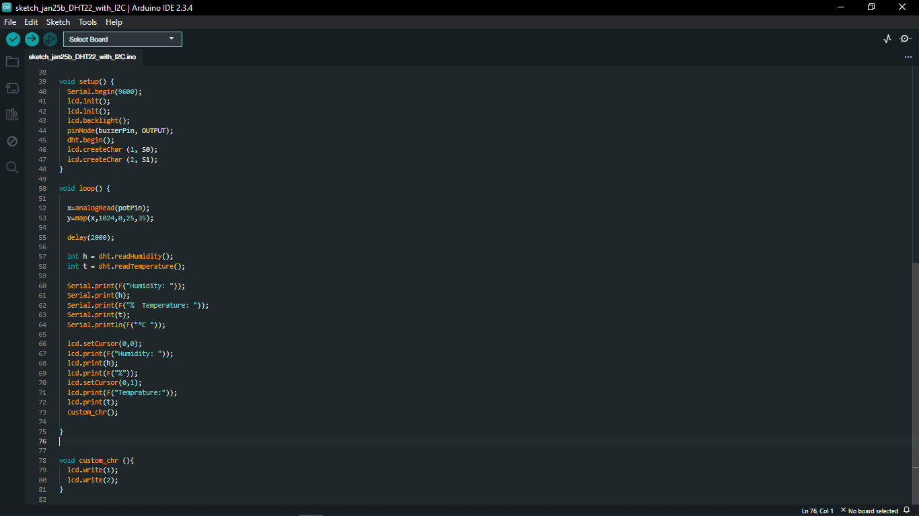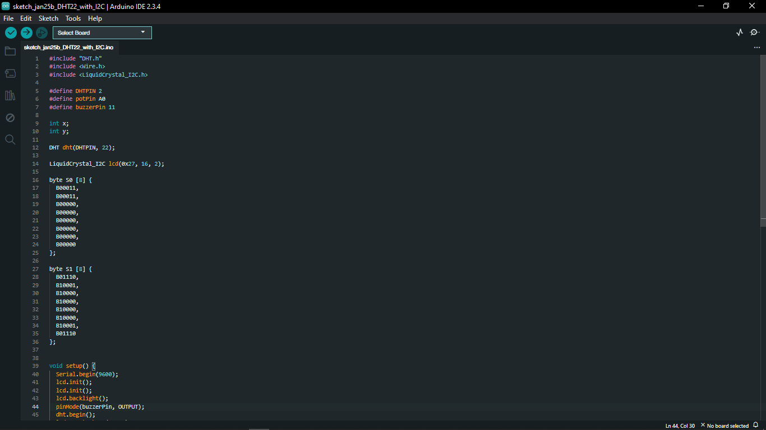

# 36. Stepper Motor

* stepper motor is a brushless DC electric motor that rotates in a series of small and discrete angular steps. Stepper motors can be set to any given step position without needing a position sensor for feedback.

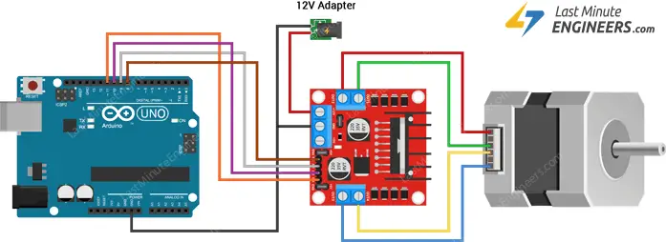

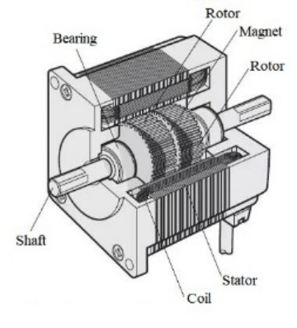

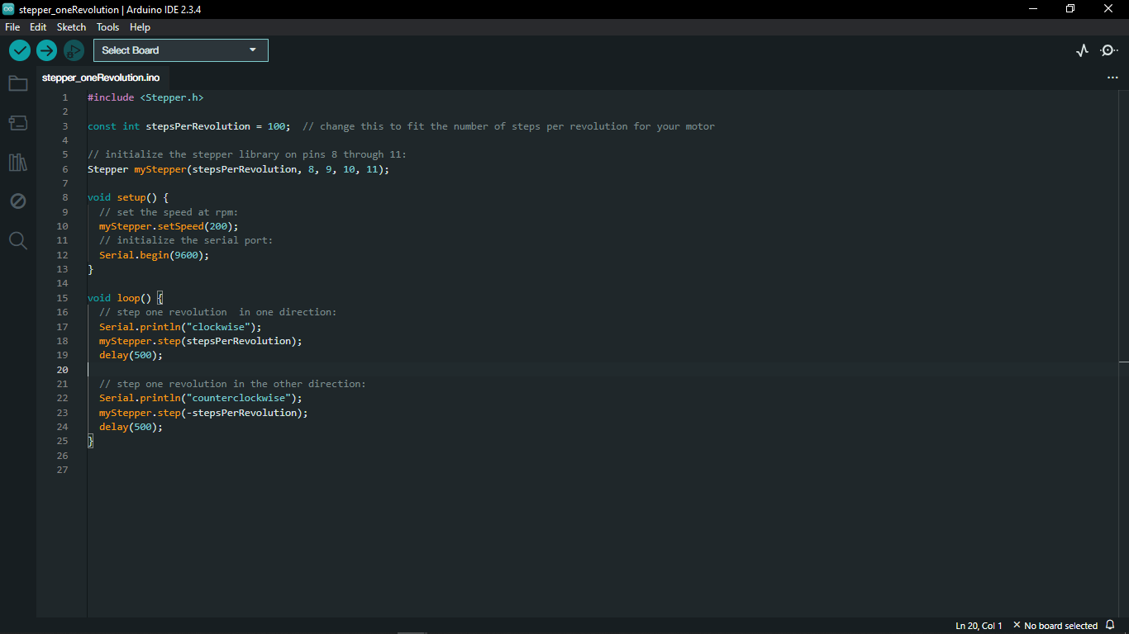

# 37. Brushless DC Motor

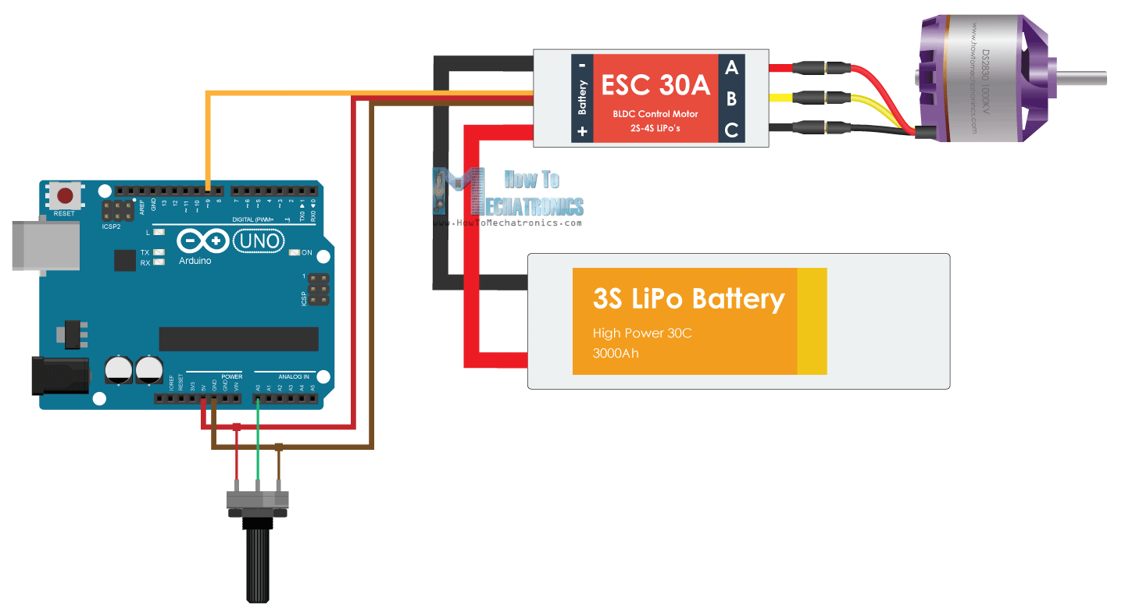

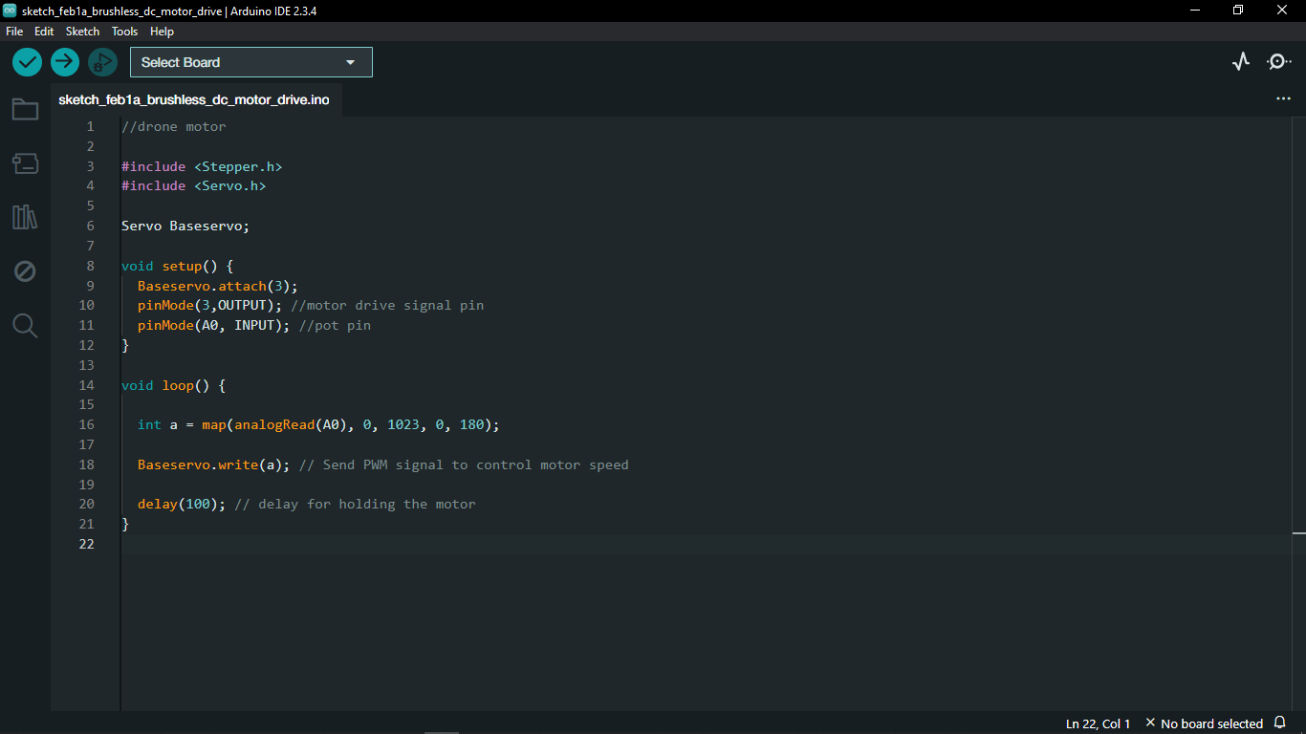

# 38. Arduino Software Serial

* Arduino Software Serial library allows users to create additional serial communication on the Arduino board using software. This is especially used when more serial ports needed than the hardware provides. With Software Serial any digital pins can be defined as RX (receive) and TX (transmit) pins for communication.

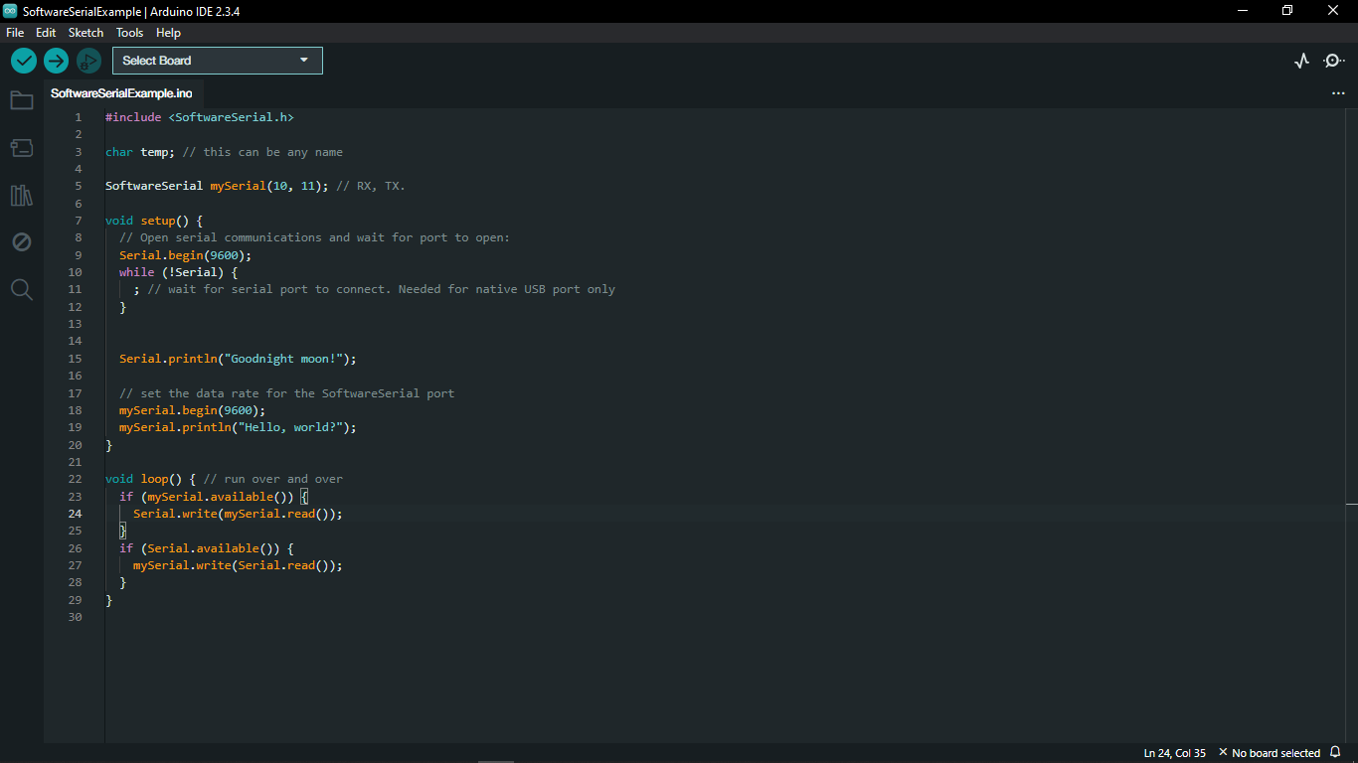

# 39. Blootooth Module

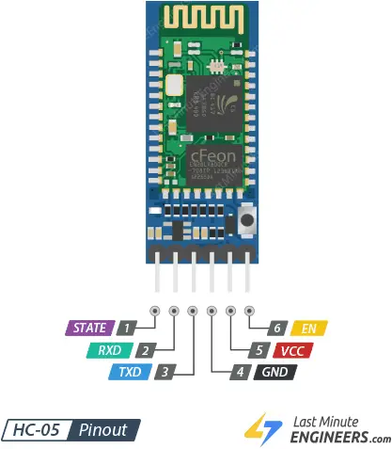

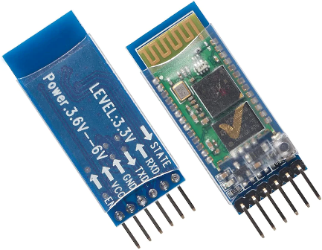

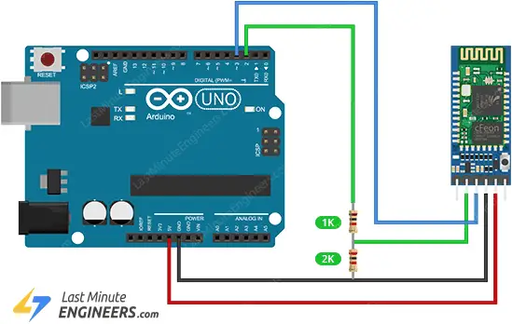

* Bluetooth module is a specialized chip that wirelessly connects two compatible devices for communication using low energy waves. These modules act as the interface between the microcontroller and the devices.

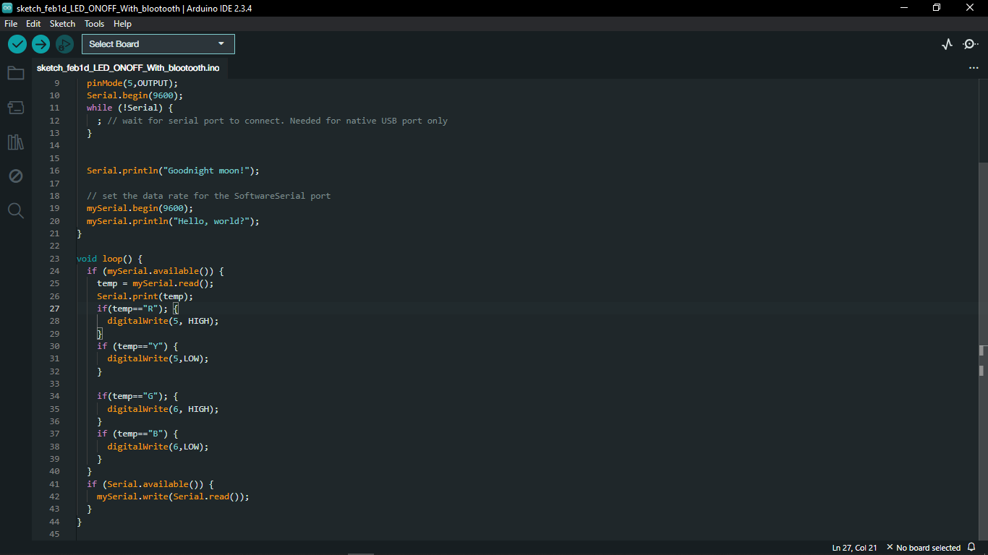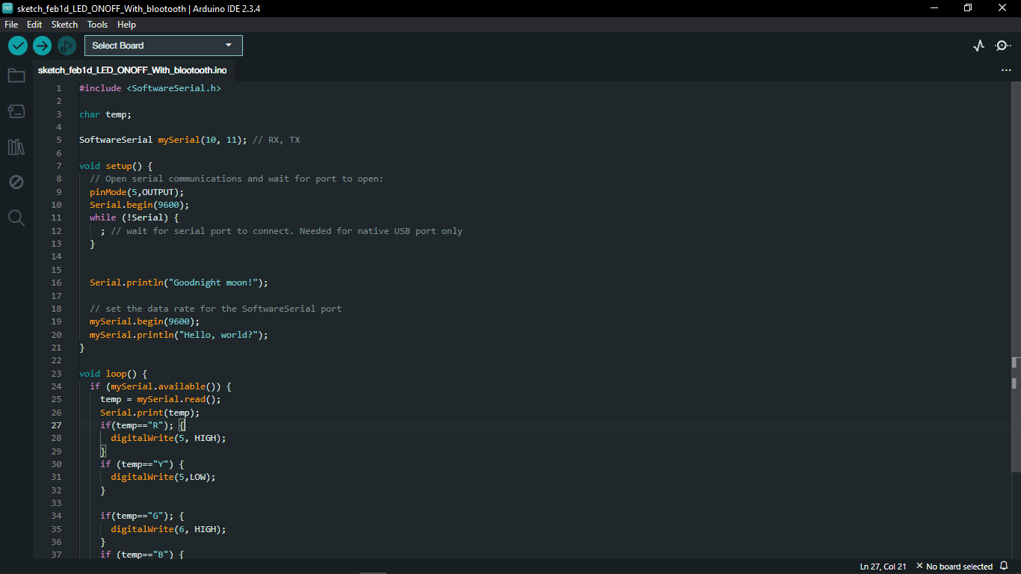

# 40. Communication of 2 UNO Boards

* 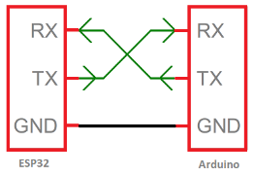This communication typically occurs via Serial UART Communication, utilizing three pins: Rx (receive), Tx (transmit), and GND (ground). In this particular project, the **master** Arduino sends commands to the **slave** Arduino through the Serial Tx Pin and receives responses via the Serial Rx Pin.

## 40.1. Master Arduino’s Code

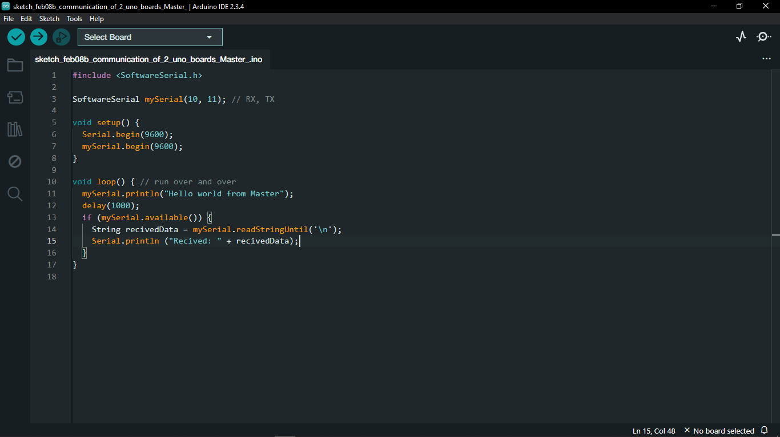

## 40.2. Slave Arduino’s Code

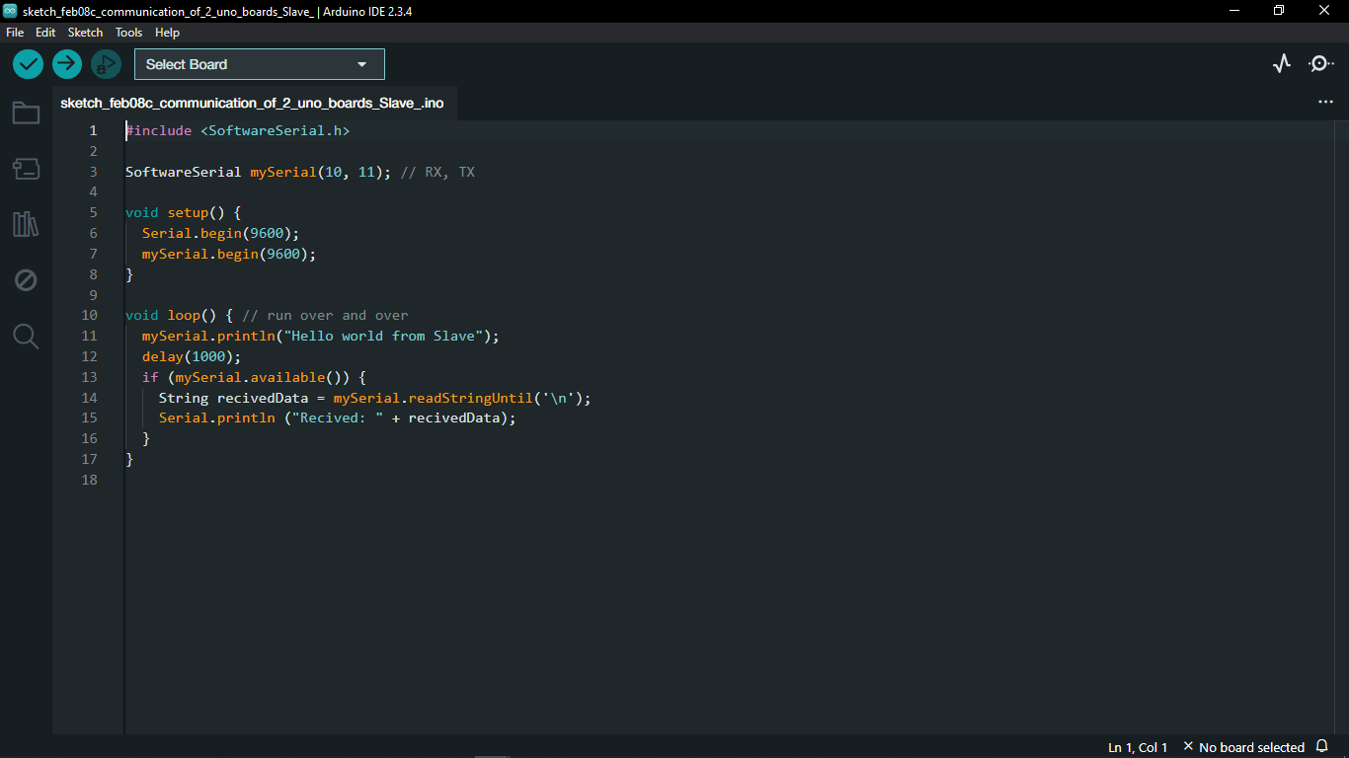

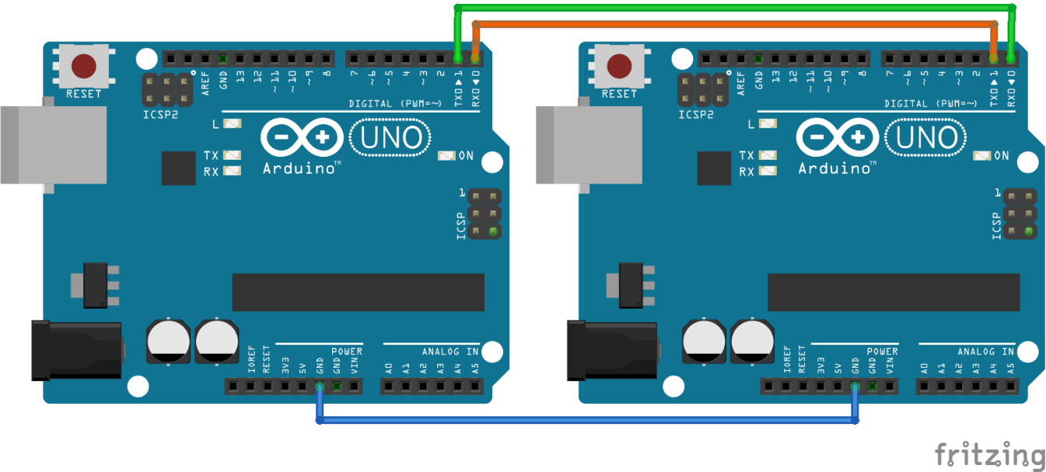

## 40.3. Control LED Using 2 Arduino Boards as Master and Slave

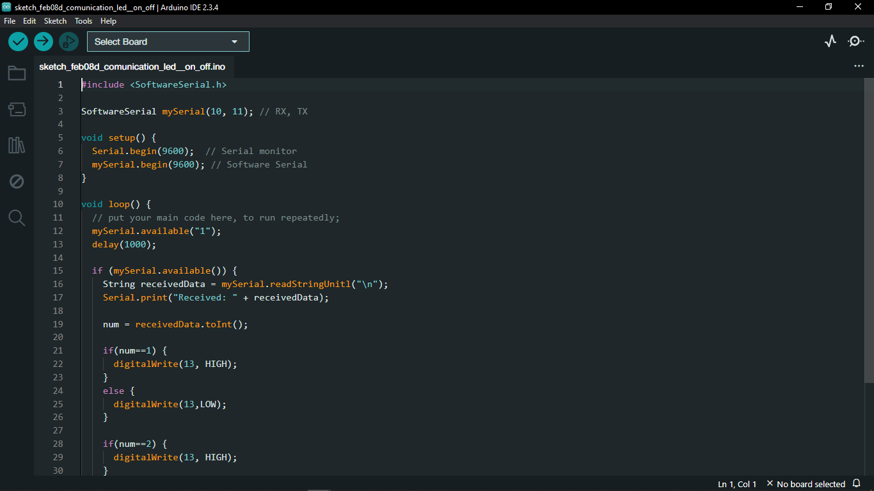

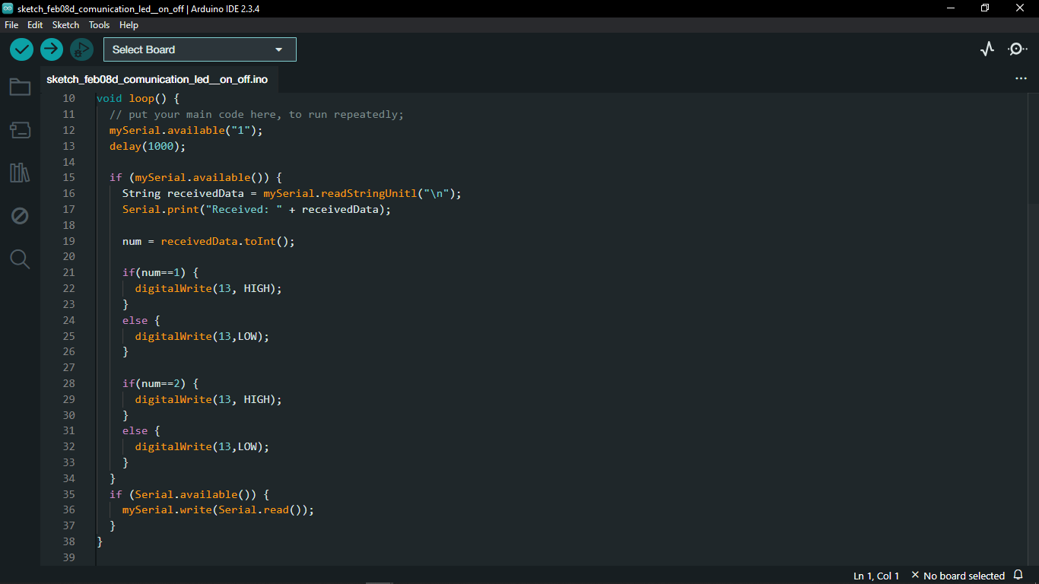

# 41. Encoder Module

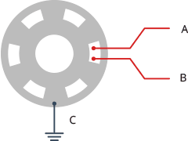

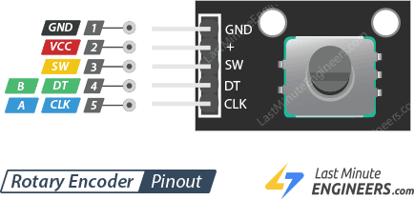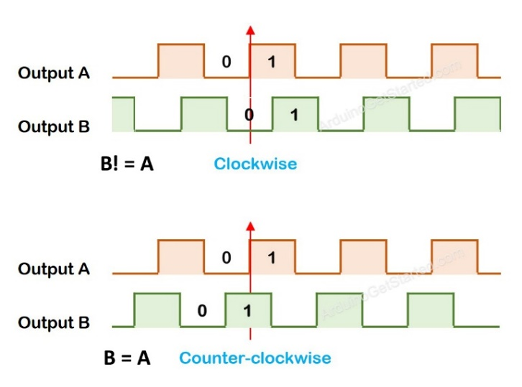

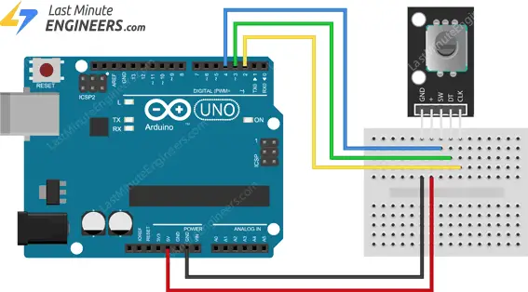

* Encoder modules constitute an integral part of various digital signal processing systems and artificial intelligence models. These modules encode the input data into a format that is easier for the system or model to interpret and process.

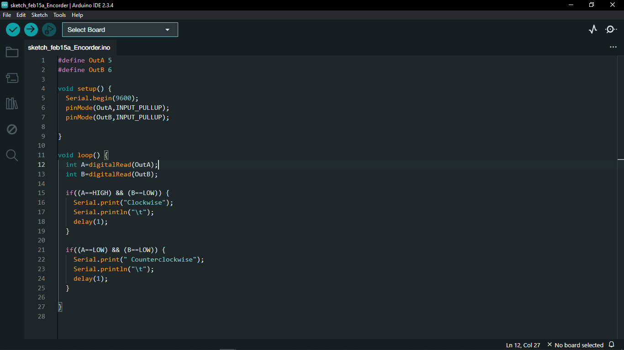

## 41.1. Encoder and Counter

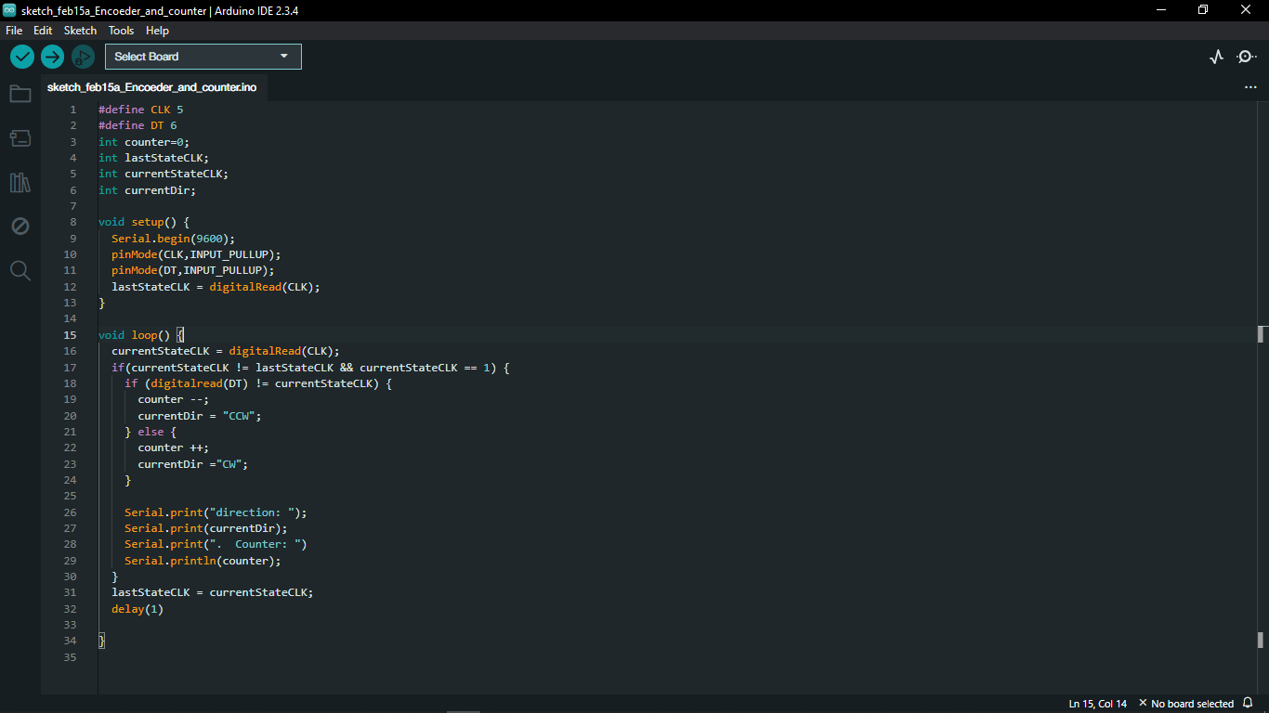

## 41.2. Encoder 1-5 Count

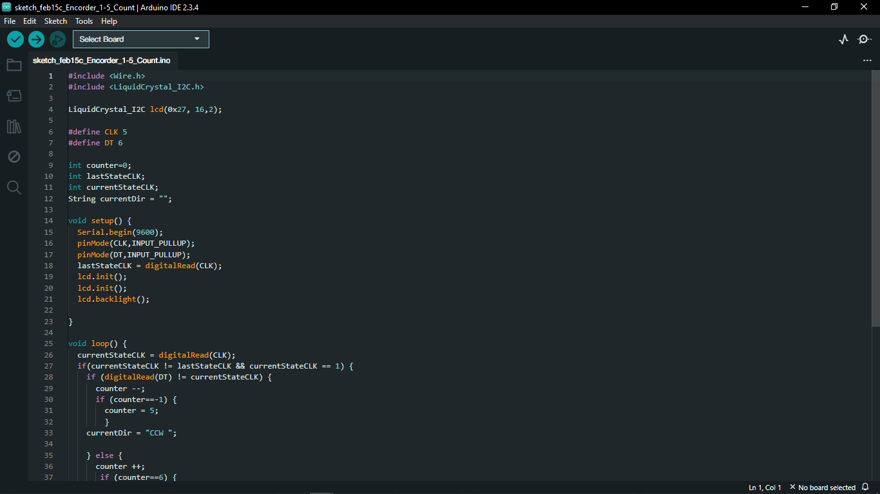

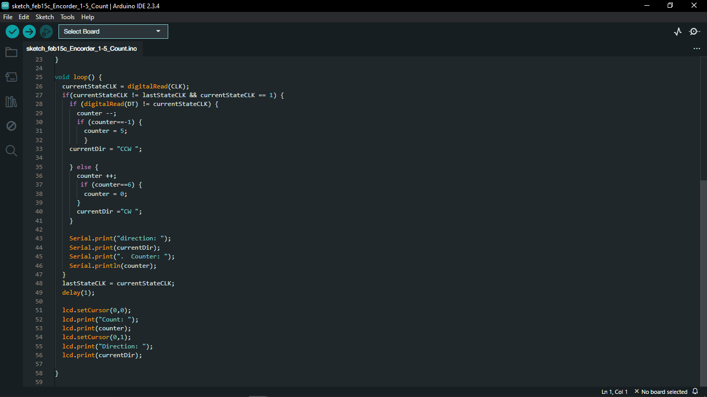

## 41.3. Encoder with Counter and LCD

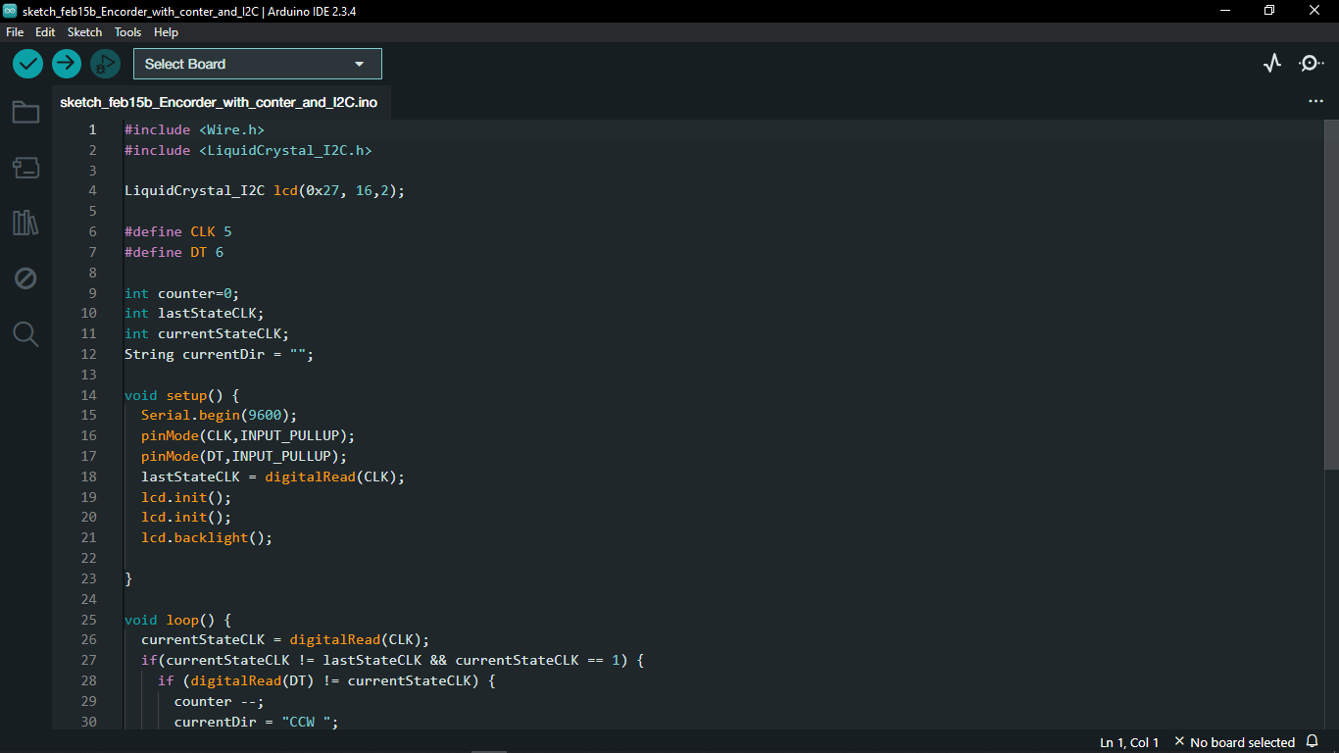

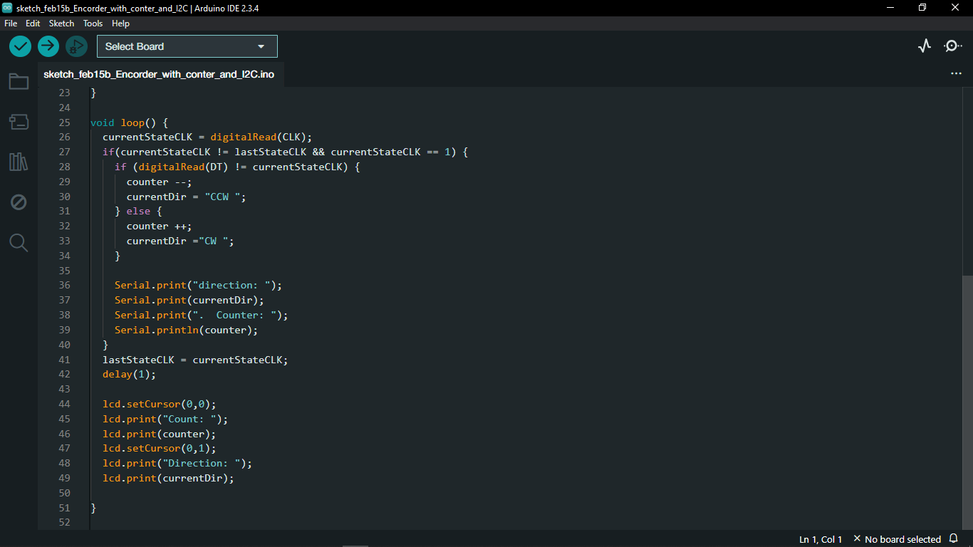

# 42. Arduino UNO Board

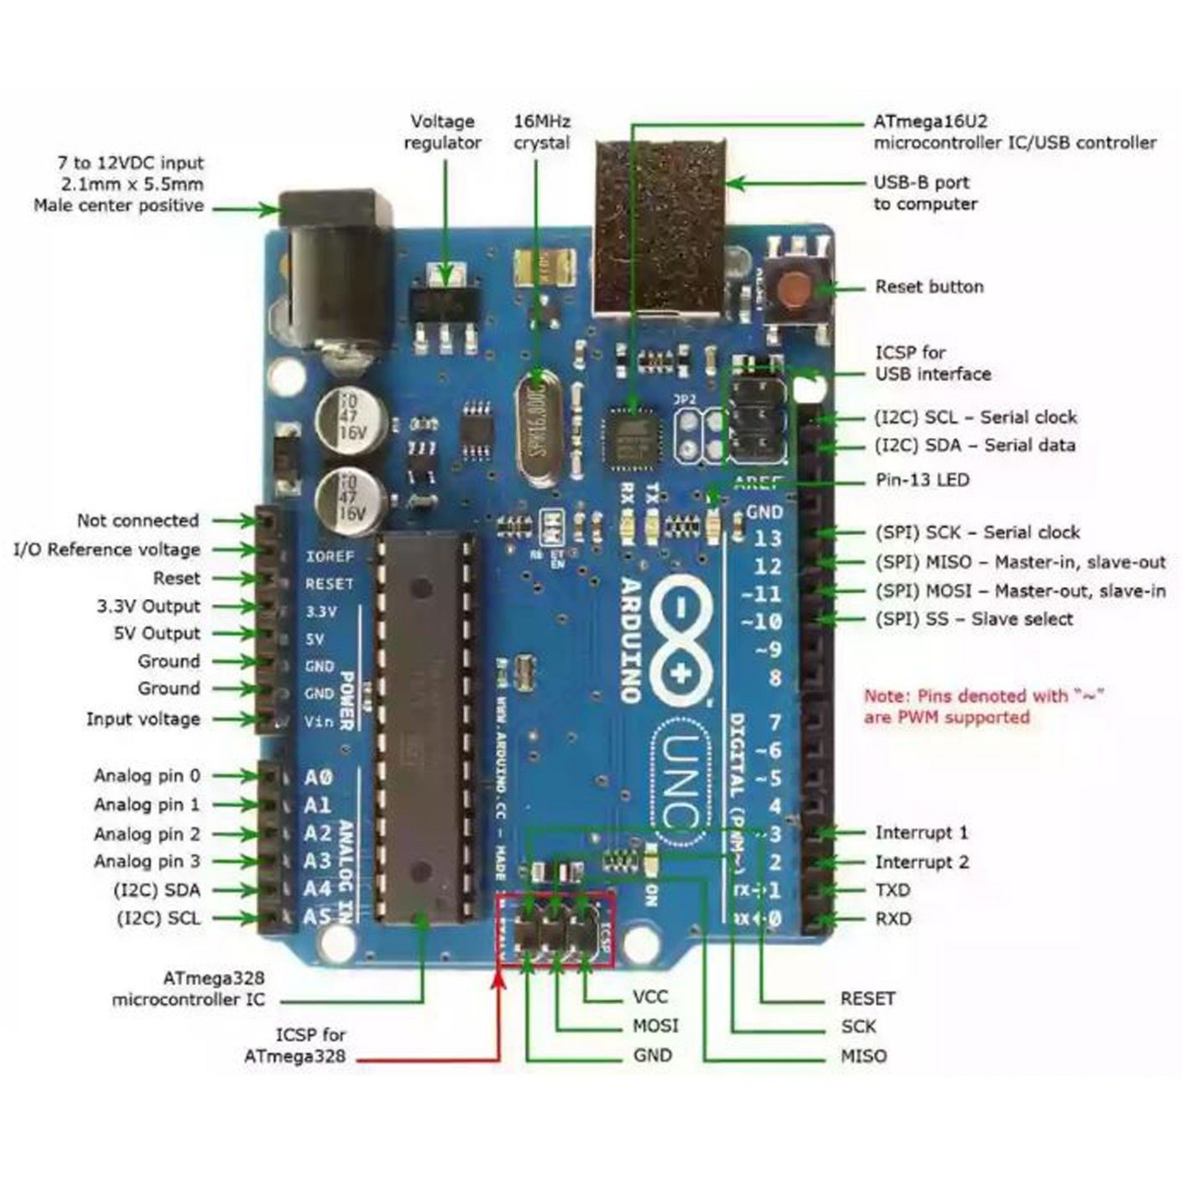

PWM output pins 3, 5, 6, 9, 10, 11

PWM input pins 2, 3

## 42.1. Digital Input/Output Pins

The Arduino Uno board has 14 digital input/output (I/O) pins labeled from 0 to 13. These 14 pins can be configured as either digital inputs or digital outputs. Out of 14 pins, 6 pins can be used as PWM (Pulse Width Modulation) output pins and 2 can be used as PWM (Pulse Width Modulation) input pins.

PWM out pins 3, 5, 6, 9, 10, and 11

PWM in pins 2 and 3.

## 42.2. Analog Input Pins

The Arduino Uno board provides 6 analogue input pins labelled from Al to A5. These pins are useful for reading values from sensors, such as temperature sensors, light sensors, and potentiometers.

Voltage Regulator It controls the voltage provided to the microcontroller and other onboard components.

## 42.3. Microcontroller

This is the main controller IC on which Arduino Code is stored. It is **Atmel ATMEGA328P** microcontroller. It is the Brain of the Arduino Board, When Arduino board is powered up it executes the instructions stored in its 32KB flash memory.

USB Connector A USB connector allows users to connect it directly to a computer or other devices for programming and communication. It serves multiple purposes. Firstly, it provides a means to power the board during development and testing phases. Secondly, the USB connection allows users to upload code to the board and facilitates serial communication between the Arduino Uno and the computer, allowing data exchange and debugging.

## 42.4. Arduino Uno Board Specifications

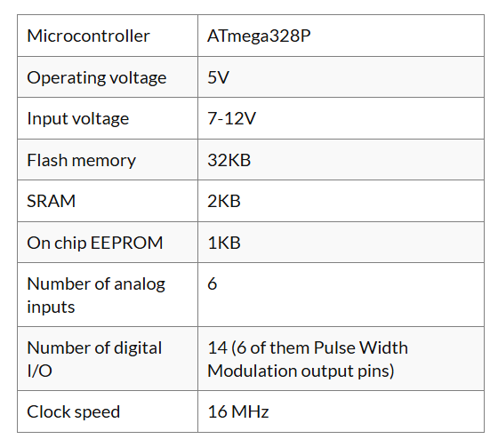

Arduino R3 has three types of memory

1. **Flash Memory (ROM)** - Stores the program/code (non-volatile)
2. **SRAM (RAM)** - Stores temporary data (volatile)
3. **EEPROM** - Stores data permanently, even after power is off

* Flash Memory (ROM): Stores your program code permanently.
* SRAM (RAM): Stores variables during program execution (limited!).
* EEPROM: Stores user data/settings permanently.

## 42.5. Logical Operators

|  |  |  |
| --- | --- | --- |
| Logical Operator | Operator Symbol | Example |
| OR | || | a || b |
| AND | && | a && b |
| NOT | ! | ! a |

## 1. For Loop -

A for loop is a loop that is used to perform an action a specified number of times.

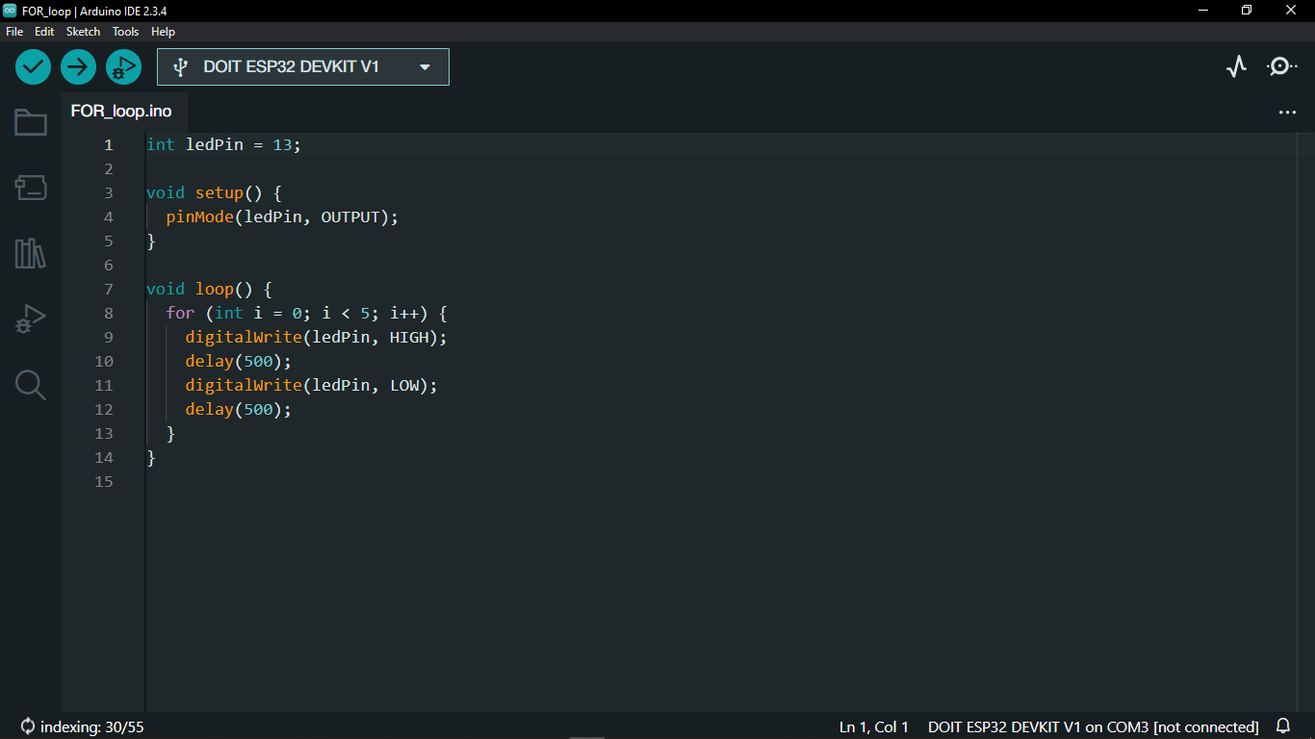

## 2. While Loop -

A while loop repeats a block of code while a specific condition remains true.

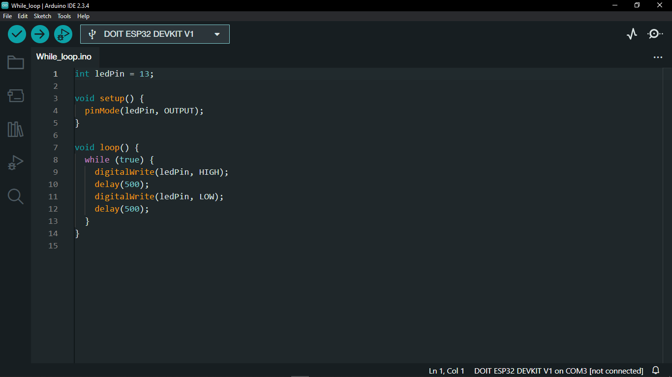

# 43. Electrically Erasable Programmable Read-Only Memory (EEPROM)

* In Arduino, EEPROM (Electrically Erasable Programmable Read-Only Memory) is a non-volatile memory that retains data even when the board is powered off. Unlike RAM (Random Access Memory) which loses its contents when power is removed, EEPROM retains its data even without power. EEPROM memory, typically around 1024 bytes.

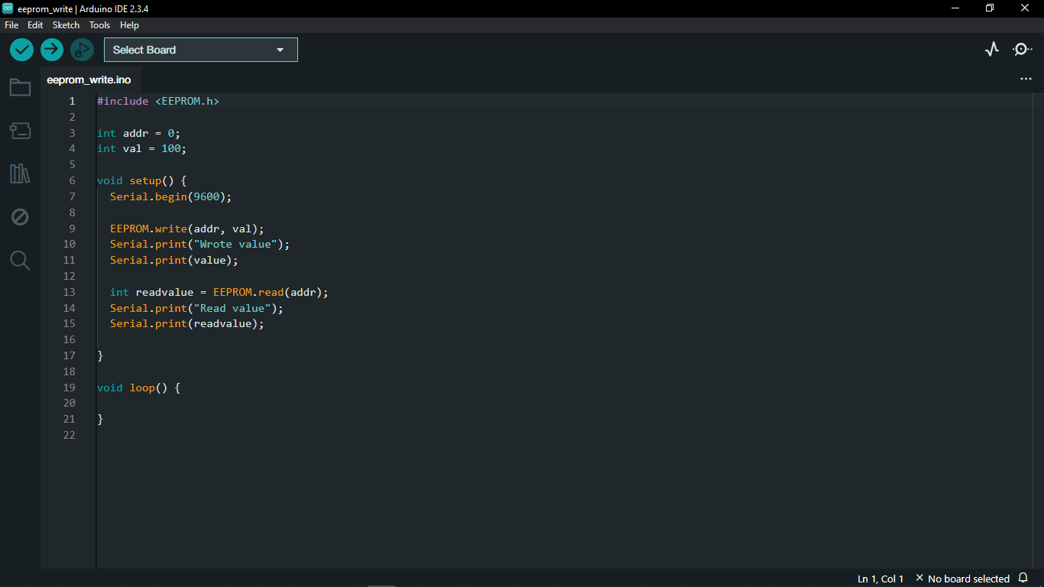

# 44. Gyroscope

Gyroscope module is a device that can measure and maintain the orientation and angular velocity of an object. It is more advanced than an accelerometer, which can only measure linear motion. 3-axis gyroscopes measure angular rate and are usually combined with an accelerometer in a common package to allow advanced algorithms like sensor fusion.

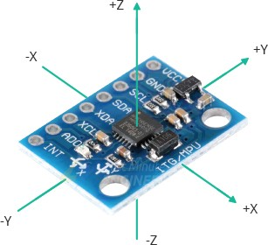

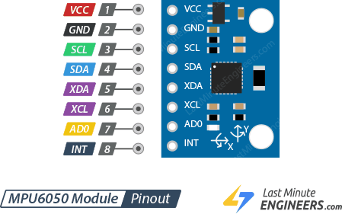

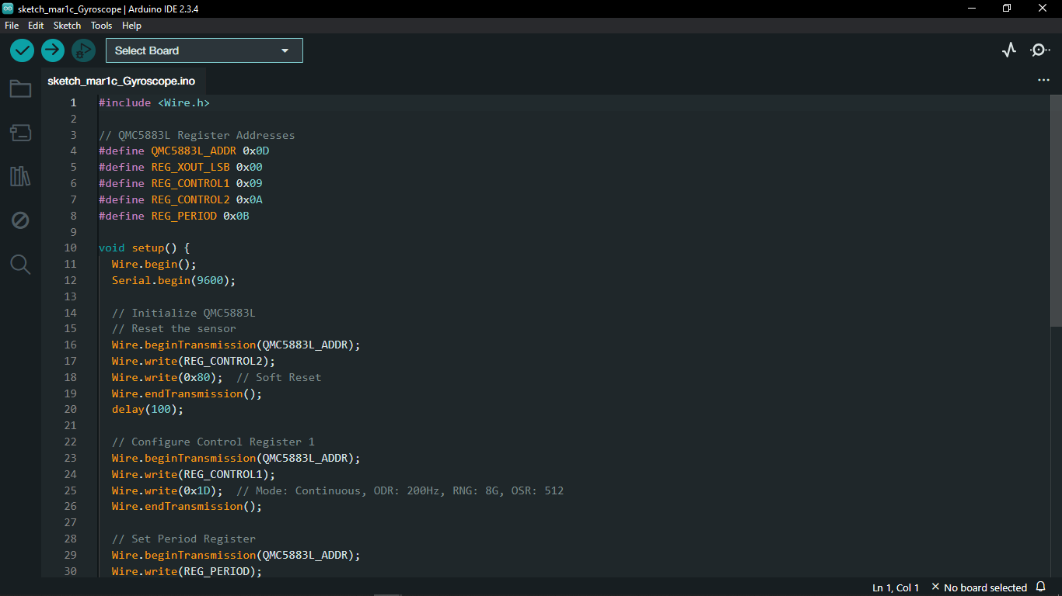





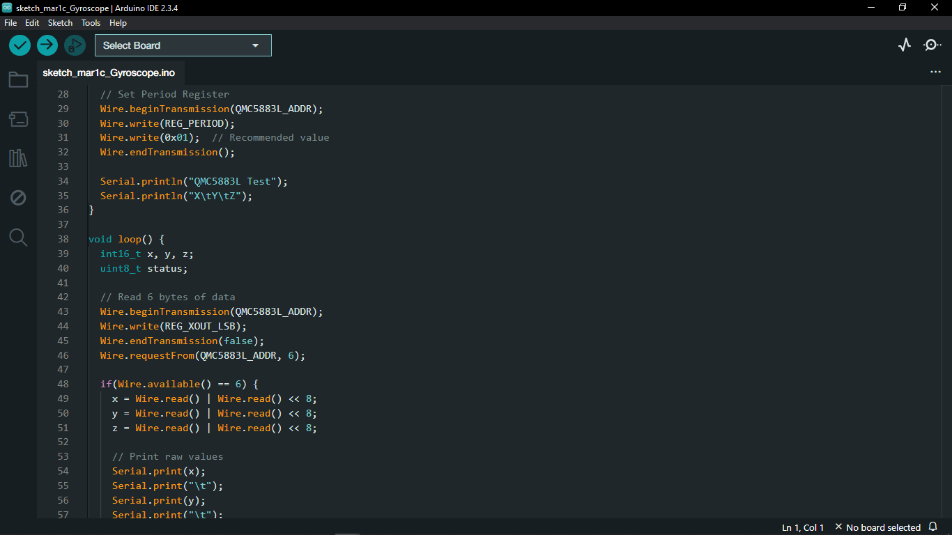

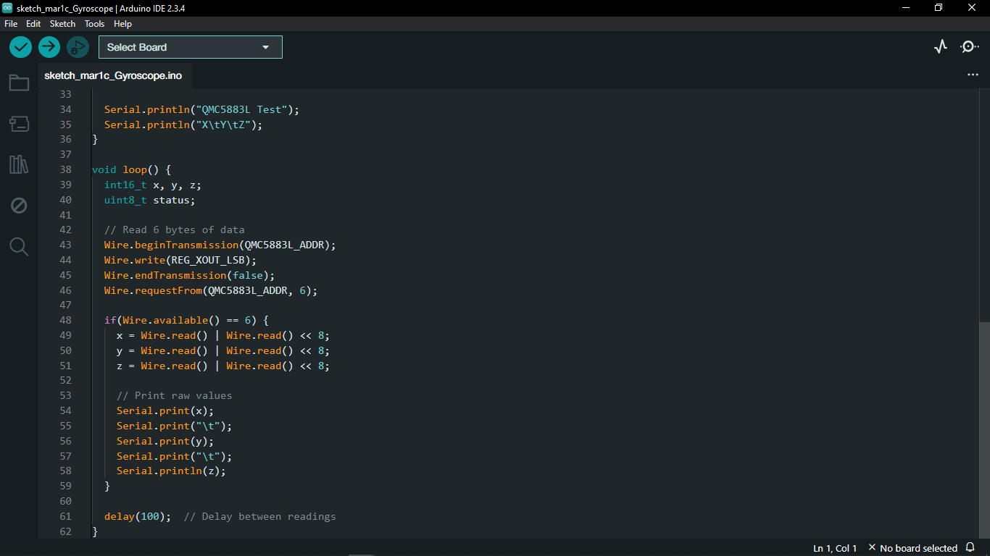

# 45. Real-Time Clock Module (RTC)

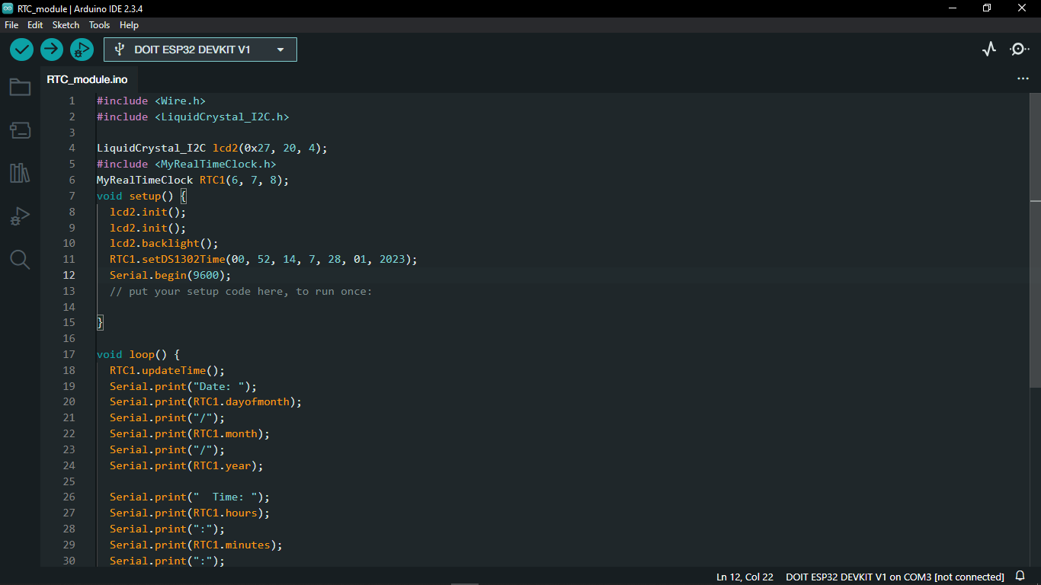

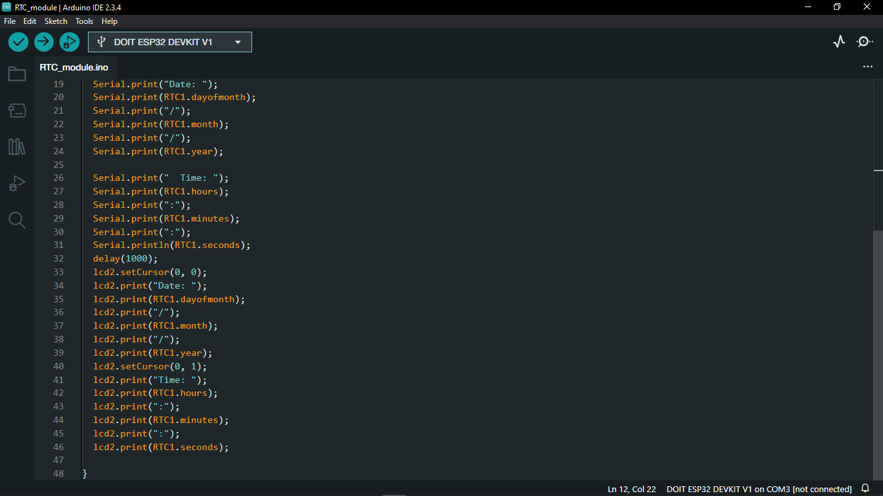

# 46. Load Cell Sensor

A load cell is a type of force transducer that measures force or weight A load cell converts a force into an electrical signal that can be measured. The electrical signal changes proportionally to the force applied.

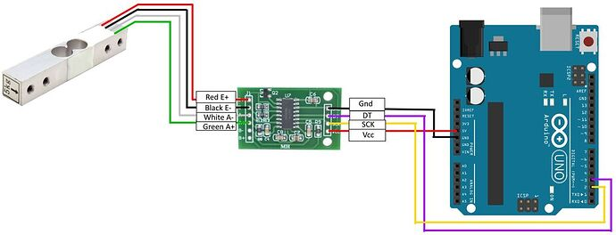

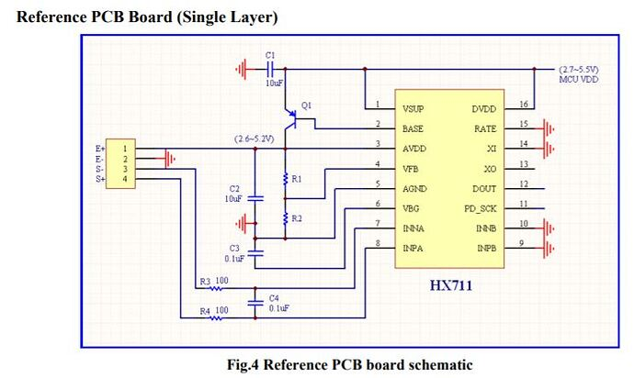

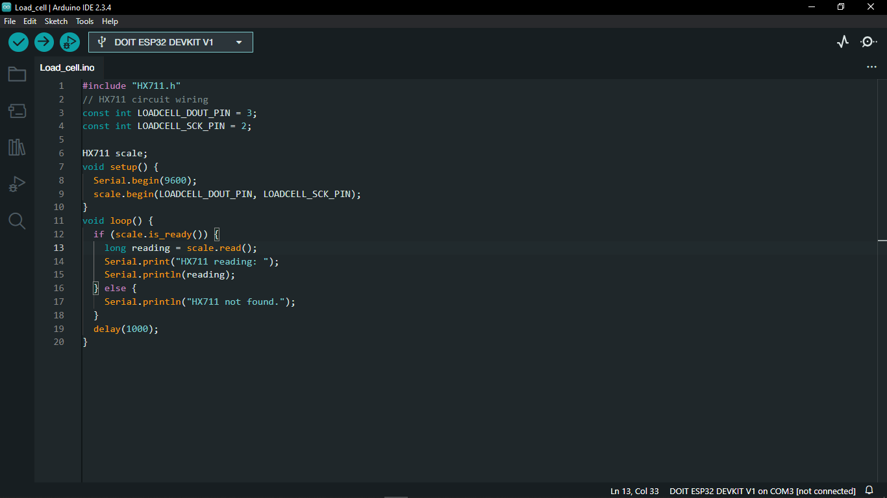

# 47. PCB Designing

## 47.1. Rectifier Circuit

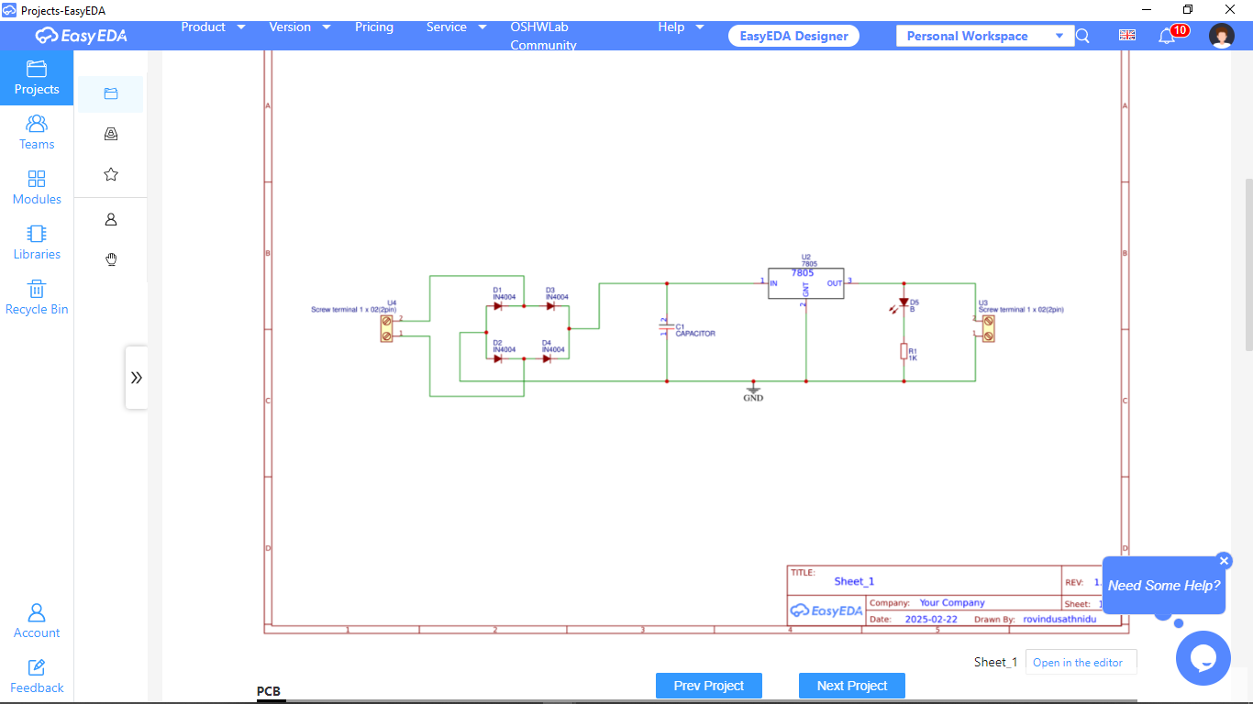

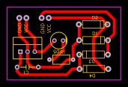

## 47.2. Arduino Board Design Using ATMega 328p

